**1.** **ACKNOWLEDGEMENT**

It is my pleasure to be indebted to various people, who directly or indirectly contributed in the development of this work and who influenced our thinking, behavior, and acts during the course of our training.

I express my sincere gratitude Mr.Lovedeep Singh**,** worthy mentor, guide and a great teacher who influenced and inspired me in many ways.

Lastly, I would like to thank the almighty and my parents for their moral support and my friends with whom I shared our day-to-day experience and received lots of suggestions that improved our quality of work.

**2.DECLARATION**

We hereby declare that the project entitled “Time Table Generator” submitted for the B.Tech. Degree is our original work and the project has not form the basis for the award of any degree, associate ship, fellowship or any other similar titles. It is authentic record of our own work carried out at **APEX TG INDIA PVT. LTD. Noida** under the guidance of Mr. Sanjeev.

**Mr. Lovedeep Singh**

(RIET Phagwara)

Manpreet Kaur

(RIET Phagwara)

Certified that the above statement made by the students is correct to the best of our knowledge and belief..

Mr. Sanjeev Kumar

**3. Company Profile**



Apex TG India Pvt. ltd

Apex T.G. India Pvt. Ltd. is a ISO 9001:2008 certified Software Development Company. Founded in 2006 and based in New Delhi; has vast experience and expertise in IT Staffing, Software Training, Project Management, Enterprise Software & Web Development, Network Architecture and Finance Systems Solutions, Web Application development, dedicated to provide custom made software services to customers need of any size within global reach. Apex provides end-to-end solution with faster implementation at an economical cost. The capabilities, experiences and relationships over years gives Apex, the expertise as well as the knowledge to cater the software solutions which enables businesses to leverage leading edge technology to gain sustainable competitive advantages in today's marketplace (http://www.apextgi.in)

**Services**

**Web Development**

Strong web development bolsters your web design so that you have error-free loading pages and a flexible web structure to support an expanding business.

Php / MySQL Development

Our talented programmers fulfill all your PHP web development requirements. We specialize in Custom PHP Applications, PHP Programming Services, PHP development and Customization, PHP Shopping Cart Development and much more.

**Graphics Designing**

Graphics Designing is one of our core services. The visual impact of professional Graphics Design services in all your marketing resources, from your Logo and Corporate Branding to printed collateral material to web presence.

**Mobile Responsive Design**

We take pride in our high quality responsive designs. Responsive Web Design is less about technology and more about design, using a set of techniques to present the website content to the viewer based on your device of choice.

**Web Designing**

A website that stands out and yet does not cost a fortune is a necessity we help fulfill. We render attractive, affordable and professional custom web design to let your business grow at a rapid pace. Our designs provide a unique brand recognition and identity for our clients.

**Website Maintenance**

Our maintenance services help to keep things fresh. We provide regular updates, clean up ,perform website software patches and upgrades for you for software like WordPress and Joomla, resize and optimize images for your website or else apply special treatments like rounded corners.

**CMS Development**

We provide customized economical CMS solutions to manage your data on the website or on the online web portal in a much easier and effective manner.Our Content Management System will be an answer to all the problems related to management and organisation of vast amount of data.

**Wordpress Development**

Our company offers WordPress web development service that are flexible enough to match your growing branding needs. This makes it best platform for corporate brochures and publishing that require frequent updates.

**Web Portal Development**

We provide a highly compatible web portal development for your business with very easy navigation, making it very easy and smooth for visitors to go through your products and services forcing them to turn into customers.

**Web Application Development**

We focus on changing the way our clients think about the web. Our apps are business-driven, user-focused, and highly innovative.

FOUNDED: 2006

Address: Noida Sec-63, E-20

Phone Number:

 08588848090

0120-4029027

Email:

 smruti@apextgi.com

**4. About Project**

**Time Table Generator**

Even though most college administrative work has been computerized, the lecture timetablescheduling is still mostly done manually due to its inherent difficulties. The manual lecture-timetable scheduling demands considerable time and efforts. The lecture-timetablescheduling is a Constraint satisfaction problem in which we find a solution that satisfies thegiven set of constraints.A college timetable is a temporal arrangement of a set of lectures and classrooms in which allgiven constraints are satisfied. Creating such timetables manually is complex and time-consuming process. By automating this process with computer assisted timetable generatorcan save a lot of precious time of administrators who are involved in creating and managingcourse timetables.

Since every college has its own timetabling problem, the commercially available software packages may not suit the need of every college. Hence we have developed practicalapproach for building lecture course timetabling system, which can be customized to fit toany colleges timetabling problem.The college lecture-timetabling problem asks us to find some time slots and classroomswhich satisfy the constraints imposed on offered.

Our Timetabling Algorithm is main component of our project which produces he HTML based timetable even / odd semester sheet as the output.Our project takes various inputs from the user such as Teacher List, Course List, SemesterList, Room List, Day List and Timeslot as well as various rules, facts and constraints usingweb based forms, which are stored in XML based knowledge base.This knowledge base serves as input to our Timetable Generator Algorithm residing on servermachine. Our knowledgebase is in the middle, because it is between our timetablingalgorithm and GUI front end which is designed in the last. After the representation of KB isstandardized, we designed the timetabling algorithm.

The design of timetabling algorithm took most of our total time. During design of algorithm,first problem was, from where to start? Second problem was, does it really going to work?But after all due to our superior design of knowledgebase, flowcharts and enough thinking ontimetabling data structure representation helped us to really boosted building our fineworking algorithm.

The proposed system is a website, which allows the student a good user interfacealso it provides a good user interface to admin & faculties, and they can easily get therequired information. The web site provides a variety of facilities to students, admin andfaculties. The main modules of the proposed system are Administrator, faculties & st

**4.1.Module Description**

Time Table Generator is a web based application which guides you about time table management. This project includes mainly two modules i.e. login and main page.

**Login:**

1. Admin
2. Student
3. Staff

**Admin:** The page require user id and password to start the application. Login is a process by which individual access to a computer system is controlled by identifying and authenticating the user through the cardinalities presented by the user. Admin can add or delete the category, subcategory etc.

**Student:** Student can register the account by clicking on new register. He/she can add the account for the various Courses. The student have to login to get more information about the time schedule.

**Staff:** Staff can register by admin. The staff have to login to get more information about the time schedule.

**4.2 Scope Of Project**

Most colleges have a number of different courses and each course has a number of subjects. Now there are limited faculties, each faculty teaching more than one subjects. So now the time table needed to schedule the faculty at provided time slots in such a way that their timings do not overlap and the time table schedule makes best use of all faculty subject demands. We use a genetic algorithm for this purpose. In our Timetable Generation algorithm we propose to utilize a timetable object. This object comprises of Classroom objects and the timetable for every them likewise a fitness score for the timetable. Fitness score relates to the quantity of crashes the timetable has regarding alternate calendars for different classes. Classroom object comprises of week objects. Week objects comprise of Days. also Days comprises of Timeslots. Timeslot has an address in which a subject, student gathering going to the address and educator showing the subject is related Also further on discussing the imperatives, We have utilized composite configuration design, which make it well extendable to include or uproot as numerous obligations. In every obligation class the condition as determined in our inquiry is now checked between two timetable objects. On the off chance that condition is fulfilled i.e there is a crash is available then the score is augmented by one.

**5. SYSTEM REQUIREMENTS**

**Hardware Requirements**

Processor : IntelDualCore.

Hard Disk : 60GB.

Floppy Drive: 1.44Mb.

Monitor: LCD Colour.

Mouse: Optical.

RAM : 512Mb.

**Software Requirements**

Operating System: Windows XP.

Language : PHP.

Database :MYSQL.

**6.Detail Description of Technology Used**

**1. PHP:-**

**6.2.1 Introduction**

PHP is now officially known as “**PHP: Hypertext Preprocessor**”. It is a server-side scripting language usually written in an HTML context. Unlike an ordinary HTML page, a PHP script is not sent directly to a client by the server; instead, it is parsed by the PHP binary or module, which is server-side installed. HTML elements in the script are left alone, but PHP code is interpreted and executed. PHP code in a script can query databases, create images, read and write files, talk to remote servers – the possibilities is endless. The output from PHP code is combined with the HTML in the script and the result sent to the user’s web-browser, therefore it can never tell the user whether the web-server uses PHP or not, because the entire browser sees is HTML.

PHP’s support for Apache and MySQL further increases its popularity. Apache is now the most-used web-server in the world, and PHP can be compiled as an Apache module. MySQL is a powerful free SQL database, and PHP provides a comprehensive set of functions for working with it. The combination of Apache, MySQL and PHP is all but unbeatable.

That doesn’t mean that PHP cannot work in other environments or with other tools. In fact, PHP supports an extensive list of databases and web-servers. While in the mid-1990s it was ok to build sites, even relatively large sites, with hundreds of individual hard-coded HTML pages, today’s webmasters are making the most of the power of databases to manage their content more effectively and to personalize their sites according to individual user preferences.

## 

## Reasons for using PHP

There are some indisputable great reasons to work with PHP. As an open source product, PHP is well supported by a talented production team and a committed user community. Furthermore, PHP can be run on all the major operating systems with most servers.

**a)** **Learning PHP is easy**Basic is easy any interpreted language should be easy to learn. Since you are isolated from the system (no pointers to use, no memory to allocate). The other advantage that all modern interpreted languages share is good associative array constructs.

**b)** **Its Performance**

While we can build an application that serves millions of pages a day on a server, when we really look at the performance of the language it sucks. We are still orders of magnitude from real performance. Not only that, but since PHP is designed around a single process model our ability to share data structures or connection pool resources is left to native code libraries.

**c)** **The low cost**

There are many languages which are available at very less cost. There are some languages which are available at very less cost like below:

* 1. PHP
  2. C
  3. C++ etc

**d**) **It’s Open Source, We can modify it**

We can modify it if you need a hole in your head! Technically the point is that it’s an open source project and they release patches often.

**e)** **Its Portability**

C is portable; it’s just the OS bits that aren’t. A lot PHP isn’t portable to Windows since people don’t use the OS abstractions to avoid some problems.

**f)It has interfaces to a large variety of database systems**

PHP supports a large variety of the database.

**Support available**

Online Support is available for using PHP.

1. **PHP Syntax**

You cannot view the PHP source code by selecting “View source” in the browser – you will only see the output from the PHP file, which is plain HTML. This is because the scripts are executed on the server before the result is sent back to the browser.

**Basic PHP Syntax**

A PHP scripting block always starts with **<?php** and ends with **?>**. A PHP scripting block can be placed anywhere in the document.

On servers with shorthand support enabled you can start a scripting block with <? And end with ?>. However, for maximum compatibility, we recommend that you use the standard form (<?php) rather than the shorthand form.

A PHP file normally contains HTML tags, just like an HTML file, and some PHP scripting code.

**6.2.2 HTML**

**HTML** or **Hyper Text Markup Language** is the standard markup language used to create web pages.

HTML was created in 1991 by Tim Berners-Lee at CERN in Switzerland. It was designed to allow scientists to display and share their research.

HTML is written in the form of HTML elements consisting of *tags* enclosed in angle brackets(like <html>). HTML tags most commonly come in pairs like <h1> and </h1>, although some tags represent *empty elements* and so are unpaired, for example <img>. The first tag in a pair is the *start tag*, and the second tag is the *end tag* (they are also called *opening tags* and *closing tags*).

The purpose of a web browser is to read HTML documents and compose them into visible or audible web pages. The browser does not display the HTML tags, but uses the tags to interpret the content of the page. HTML describes the structure of a website semantically along with cues for presentation, making it a markup language rather than a programming language.

HTML elements form the building blocks of all websites.

HTML allows images and objects to be embedded and can be used to create interactive forms. It provides a means to create structured documents by denoting structural semantics for text such as headings, paragraphs, lists, links, quotes and other items. It can embed scripts written in languages such as Java Script which affect the behavior of HTML web pages.

HTML is descriptive markup language. Library of various markup languages is defined in various browsers.

**a) HTML Images - The <img> Tag and the Src Attribute**

In HTML, images are defined with the <img> tag.

The <img> tag is empty, which means that it contains attributes only, and has no closing tag.

To display an image on a page, you need to use the src attribute. Src stands for "source". The value of the src attribute is the URL of the image you want to display.

**Syntax for defining an image:**

<imgsrc="*url*" alt="*some_text*">

**b) HTML FORMS**

HTML forms are used to pass data to a server.

|  |
| --- |
| The <form> tag is used to create an HTML form:  <form> . *input elements* . </form> |

An HTML form can contain input elements like text fields, checkboxes, radio-buttons, submit buttons and more. A form can also contain select lists, textarea, fieldset, legend, and label elements.

**c)** **Image tag (<img>) :**

To add an image to an HTML document, we just need to include an <IMG> tag with a

reference to the desired image. The <IMG> tag is an empty element i.e. it doesn’t require a

closing tag and we can use it to include from small icons to large images.

**Syntax: <imgsrc=”URL” alt=”alternative text”>**

**d) HTML Lists :**

|  |  |
| --- | --- |
| An ordered list:   * The first list item * The second list item * The third list item | An unordered list:   * List item * List item * List item |

**6.2.3 HTML 5**

HTML5 will be the new standard for HTML. The previous version of HTML, HTML 4.01,

came in 1999. The web has changed a lot since then. HTML5 is still a work in progress.

However, the major browsers support many of the new HTML5 elements and APIs.

HTML5 is cooperation between the World Wide Web Consortium (W3C) and the Web

Hypertext Application Technology Working Group (WHATWG).

WHATWG was working with web forms and applications, and W3C was working with

XHTML 2.0. In 2006, they decided to cooperate and create a new version of HTML.

Some rules for HTML5 were established:

a) New features should be based on HTML, CSS, DOM, and JavaScript

b) Reduce the need for external plug-ins (like Flash)

c) Better error handling

d) More markup to replace scripting

e) HTML5 should be device independent

f) The development process should be visible to the public

**6.2.4 CSS**

**CSS tutorial** or CSS 3 tutorial provides basic and advanced concepts of CSS technology. Our CSS tutorial is developed for beginners and professionals. The major points of CSS are given below:

1. CSS stands for Cascading Style Sheet.
2. CSS is used to design HTML tags.
3. CSS is a widely used language on the web.
4. HTML, CSS and JavaScript are used for web designing. It helps the web designers to apply style on HTML tags.

**Cascading Style Sheets** (**CSS**) is a style sheet language used for describing the look and formatting of a document written in a markup language. While most often used to style web pages and user interfaces written in HTML and XHTML, the language can be applied to any kind of XML document, including plain XML, SVG and XUL. CSS is a cornerstone specification of the web and almost all web pages use CSS style sheets to describe their presentation.

CSS is designed primarily to enable the separation of document content from document presentation, including elements such as the layout, colors, and fonts. This separation can improve content accessibility, provide more flexibility and control in the specification of presentation characteristics.

CSS can also allow the same markup page to be presented in different styles for different rendering methods, such as on-screen, in print, by voice (when read out by a speech-based browser or screen reader) and on Braille-based, tactile devices.

It can also be used to allow the web page to display differently depending on the screen size or device on which it is being viewed. While the author of a document typically links that document to a CSS file, readers can use a different style sheet, perhaps one on their own computer, to override the one the author has specified.

With plain HTML you define the colors and sizes of text and tables throughout your pages. If

you want to change a certain element you will therefore have to work your way through the

document and change it. With CSS you define the colors and sizes in "styles". Then as you

write your documents you refer to the styles. Therefore: if you change a certain style it will

change the look of your entire site. Another big advantage is that CSS offers much more

detailed attributes than plain HTML for defining the look and feel of your site.

**6.2.5 JAVASCRIPT**

**JavaScript** (**JS**) is a dynamic computer programming language. It is most commonly used as part of web browsers, whose implementations allow client-side scripts to interact with the user, control the browser, communicate asynchronously, and alter the document content that is displayed. It is also being used in server-side network programming (with Node.js), game development and the creation of desktop and mobile applications.

JavaScript is a prototype-based scripting language with dynamic typing and has first-class functions. Its syntax was influenced by C. JavaScript copies many names and naming conventions from Java, but the two languages are otherwise unrelated and have very different semantics. The key design principles within JavaScript are taken from the Self and Scheme programming languages. It is a multi-paradigm language, supporting object-oriented, imperative, and functional programming styles.

The application of JavaScript in use outside of web pages—for example, in PDF documents, site-specific browsers, and desktop widgets—is also significant. Newer and faster JavaScript

VMs and platforms built upon them (notably Node.js) have also increased the popularity of JavaScript for server-side web applications. On the client side, JavaScript was traditionally implemented as an interpreted language but just-in-time compilation is now performed by recent (post-2012) browsers.

JavaScript was formalized in the ECMA Script language standard and is primarily used as part of a web browser (client-side JavaScript). This enables programmatic access to objects within a host environment.

JavaScript is the most popular programming language in the world.

It is the language for HTML, for the Web, for computers, servers, laptops, tablets, smart phones, and more.

You can use JavaScript to:

a) Change HTML elements

1. Delete HTML elements
2. Create new HTML elements
3. Copy and clone HTML elements

**7. About Front End:**

The front end is an [interface](https://en.wikipedia.org/wiki/Interface_(computer_science)) between the user and the back end. The front and back ends may be distributed amongst one or more systems.

In [network computing](https://en.wikipedia.org/wiki/Computer_network), *front end* can refer to any hardware that optimizes or protects network traffic. It is called [application front-end hardware](https://en.wikipedia.org/wiki/Denial_of_service#Application_front_end_hardware) because it is placed on the network's outward-facing front end or boundary. Network traffic passes through the front-end hardware before entering the network.

In [compilers](https://en.wikipedia.org/wiki/Compilers), the [front end](https://en.wikipedia.org/wiki/Compilers#Front_end) translates a computer programming [source code](https://en.wikipedia.org/wiki/Source_code) into an [intermediate representation](https://en.wikipedia.org/wiki/Intermediate_representation), and the back end works with the intermediate representation to produce code in a computer output language. The back end usually optimizes to produce code that runs faster. The front-end/back-end distinction can separate the [parser](https://en.wikipedia.org/wiki/Parsing) section that deals with source code and the back end that [generates code and optimizes](https://en.wikipedia.org/wiki/Code_generation_(compiler)).

These days, front-end development refers to the part of the web users interact with. In the past, web development consisted of people who worked with Photoshop and those who could code HTML and CSS. Now, developers need a handle of programs like Photoshop and be able to code not only in HTML and CSS, but also JavaScript or jQuery, which is a compiled library of JavaScript.

**7.1 Architecture of Front End user:**

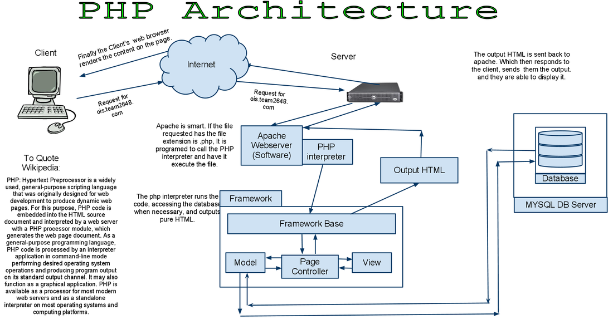

**7.1.1 Architecture and Concepts**

The query cache plugin is implemented as a PHP extension. It is written in C and operates under the hood of PHP. During the startup of the PHP interpreter, it gets registered as a [mysqlnd](http://php.net/manual/en/book.mysqlnd.php) plugin to replace selected mysqlnd C methods. Hereby, it can change the behaviour of any PHP MySQL extension ([mysqli](http://php.net/manual/en/ref.mysqli.php), [PDO_MYSQL](http://php.net/manual/en/ref.pdo-mysql.php), [mysql](http://php.net/manual/en/ref.mysql.php)) compiled to use the mysqlnd library without changing the extensions API. This makes the plugin compatible with each and every PHP MySQL application. Because existing APIs are not changed, it is almost transparent to use. Please, see the [mysqlnd plugin API description](http://php.net/manual/en/mysqlnd.plugin.php) for a discussion of the advantages of the plugin architecture and a comparison with proxy based solutions.

**7.1.2 Transparent to use**

At PHP run time PECL/mysqlnd_qc can proxy queries send from PHP ([mysqlnd](http://php.net/manual/en/book.mysqlnd.php)) to the MySQL server. It then inspects the statement string to find whether it shall cache its results. If so, result set is cached using a storage handler and further executions of the statement are served from the cache for a user-defined period. The Time to Live (TTL) of the cache entry can either be set globally or on a per statement basis.

A statement is either cached if the plugin is instructed to cache all statements globally using a or, if the query string starts with the SQL hint (*/*qc=on*/*). The plugin is capable of caching any query issued by calling appropriate API calls of any of the existing PHP MySQL extensions.

**7.1.3 Flexible storage: various storage handler**

Various storage handler are supported to offer different scopes for cache entries. Different scopes allow for different degrees in sharing cache entries among clients.

1. *default* (built-in): process memory, scope: process, one or more web requests depending on PHP deployment model used
2. *APC*: shared memory, scope: single server, multiple web requests
3. *SQLite*: memory or file, scope: single server, multiple web requests
4. *MEMCACHE*: main memory, scope: single or multiple server, multiple web requests
5. *user* (built-in): user-defined - any, scope: user-defined - any

Support for the *APC*, *SQLite* and *MEMCACHE* storage handler has to be enabled at compile time. The *default* and *user* handler are built-in. It is possible to switch between compiled-in storage handlers on a per query basis at run time.

**7.1.4 Built-in slam defense to avoid overloading**

To avoid overload situations the cache plugin has a built-in slam defense mechanism. If a popular cache entries expires many clients using the cache entries will try to refresh the cache entry. For the duration of the refresh many clients may access the database server concurrently. In the worst case, the database server becomes overloaded and it takes more and more time to refresh the cache entry, which in turn lets more and more clients try to refresh the cache entry. To prevent this from happening the plugin has a slam defense mechanism. If slam defense is enabled and the plugin detects an expired cache entry it extends the life time of the cache entry before it refreshes the cache entry. This way other concurrent accesses to the expired cache entry are still served from the cache for a certain time.The other concurrent accesses to not trigger a concurrent refresh. Ideally, the cache entry gets refreshed by the client which extended the cache entries lifespan before other clients try to refresh the cache and potentially cause an overload situation.

**7.1.5 Unique approach to caching**

PECL/mysqlnd_qc has a unique approach to caching result sets that is superior to application based cache solutions. Application based solutions first fetch a result set into PHP variables. Then, the PHP variables are serialized for storage in a persistent cache, and then unserialized when fetching. The mysqlnd query cache stores the raw wire protocol data sent from MySQL to PHP in its cache and replays it, if still valid, on a cache hit. This way, it saves an extra serialization step for a cache put that all application based solutions have to do. It can store the raw wire protocol data in the cache without having to serialize into a PHP variable first and deserializing the PHP variable for storing in the cache a

**7.2 Software & Tools Used:**

**1. PHP:-**

**7.2.1 Introduction**

PHP is now officially known as “**PHP: Hypertext Preprocessor**”. It is a server-side scripting language usually written in an HTML context. Unlike an ordinary HTML page, a PHP script is not sent directly to a client by the server; instead, it is parsed by the PHP binary or module, which is server-side installed. HTML elements in the script are left alone, but PHP code is interpreted and executed. PHP code in a script can query databases, create images, read and write files, talk to remote servers – the possibilities is endless. The output from PHP code is combined with the HTML in the script and the result sent to the user’s web-browser, therefore it can never tell the user whether the web-server uses PHP or not, because the entire browser sees is HTML.

PHP’s support for Apache and MySQL further increases its popularity. Apache is now the most-used web-server in the world, and PHP can be compiled as an Apache module. MySQL is a powerful free SQL database, and PHP provides a comprehensive set of functions for working with it. The combination of Apache, MySQL and PHP is all but unbeatable.

That doesn’t mean that PHP cannot work in other environments or with other tools. In fact, PHP supports an extensive list of databases and web-servers. While in the mid-1990s it was ok to build sites, even relatively large sites, with hundreds of individual hard-coded HTML pages, today’s webmasters are making the most of the power of databases to manage their content more effectively and to personalize their sites according to individual user preferences.

## Reasons for using PHP

There are some indisputable great reasons to work with PHP. As an open source product, PHP is well supported by a talented production team and a committed user community. Furthermore, PHP can be run on all the major operating systems with most servers.

**a)** **Learning PHP is easy**Basic is easy any interpreted language should be easy to learn. Since you are isolated from the system (no pointers to use, no memory to allocate). The other advantage that all modern interpreted languages share is good associative array constructs.

**b)** **Its Performance**

While we can build an application that serves millions of pages a day on a server, when we really look at the performance of the language it sucks. We are still orders of magnitude from real performance. Not only that, but since PHP is designed around a single process model our ability to share data structures or connection pool resources is left to native code libraries.

**c)** **The low cost**

There are many languages which are available at very less cost. There are some languages which are available at very less cost like below:

* 1. PHP
  2. C
  3. C++ etc

**d**) **It’s Open Source, We can modify it**

We can modify it if you need a hole in your head! Technically the point is that it’s an open source project and they release patches often.

**e)** **Its Portability**

C is portable; it’s just the OS bits that aren’t. A lot PHP isn’t portable to Windows since people don’t use the OS abstractions to avoid some problems.

**f)It has interfaces to a large variety of database systems**

PHP supports a large variety of the database.

**Support available**

Online Support is available for using PHP.

1. **PHP Syntax**

You cannot view the PHP source code by selecting “View source” in the browser – you will only see the output from the PHP file, which is plain HTML. This is because the scripts are executed on the server before the result is sent back to the browser.

**Basic PHP Syntax**

A PHP scripting block always starts with **<?php** and ends with **?>**. A PHP scripting block can be placed anywhere in the document. On servers with shorthand support enabled you can start a scripting block with <? And end with ?>. However, for maximum compatibility, we recommend that you use the standard form (<?php) rather than the shorthand form.

A PHP file normally contains HTML tags, just like an HTML file, and some PHP scripting code.

**7.2.2 HTML**

**HTML** or **Hyper Text Markup Language** is the standard markup language used to create web pages.

HTML was created in 1991 by Tim Berners-Lee at CERN in Switzerland. It was designed to allow scientists to display and share their research.

HTML is written in the form of HTML elements consisting of *tags* enclosed in angle brackets(like <html>). HTML tags most commonly come in pairs like <h1> and </h1>, although some tags represent *empty elements* and so are unpaired, for example <img>. The first tag in a pair is the *start tag*, and the second tag is the *end tag* (they are also called *opening tags* and *closing tags*).

The purpose of a web browser is to read HTML documents and compose them into visible or audible web pages. The browser does not display the HTML tags, but uses the tags to interpret the content of the page. HTML describes the structure of a website semantically along with cues for presentation, making it a markup language rather than a programming language.

HTML elements form the building blocks of all websites. HTML allows images and objects to be embedded and can be used to create interactive forms. It provides a means to create structured documents by denoting structural semantics for text such as headings, paragraphs, lists, links, quotes and other items. It can embed scripts written in languages such as Java Script which affect the behavior of HTML web pages.

HTML is descriptive markup language. Library of various markup languages is defined in various browsers.

**a) HTML Images - The <img> Tag and the Src Attribute**

In HTML, images are defined with the <img> tag.

The <img> tag is empty, which means that it contains attributes only, and has no closing tag.

To display an image on a page, you need to use the src attribute. Src stands for "source". The value of the src attribute is the URL of the image you want to display.

**Syntax for defining an image:**

<imgsrc="*url*" alt="*some_text*">

**b) HTML FORMS**

HTML forms are used to pass data to a server.

|  |
| --- |
| The <form> tag is used to create an HTML form:  <form> . *input elements* . </form> |

An HTML form can contain input elements like text fields, checkboxes, radio-buttons, submit buttons and more. A form can also contain select lists, textarea, fieldset, legend, and label elements.

**c)** **Image tag (<img>) :**

To add an image to an HTML document, we just need to include an <IMG> tag with a

reference to the desired image. The <IMG> tag is an empty element i.e. it doesn’t require a

closing tag and we can use it to include from small icons to large images.

**Syntax: <imgsrc=”URL” alt=”alternative text”>**

**d) HTML Lists :**

|  |  |
| --- | --- |
| An ordered list:   * The first list item * The second list item * The third list item | An unordered list:   * List item * List item * List item |

**7.2.3 HTML 5**

HTML5 will be the new standard for HTML. The previous version of HTML, HTML 4.01,

came in 1999. The web has changed a lot since then. HTML5 is still a work in progress.

However, the major browsers support many of the new HTML5 elements and APIs.

HTML5 is cooperation between the World Wide Web Consortium (W3C) and the Web

Hypertext Application Technology Working Group (WHATWG).

WHATWG was working with web forms and applications, and W3C was working with

XHTML 2.0. In 2006, they decided to cooperate and create a new version of HTML.

Some rules for HTML5 were established:

a) New features should be based on HTML, CSS, DOM, and JavaScript

b) Reduce the need for external plug-ins (like Flash)

c) Better error handling

d) More markup to replace scripting

e) HTML5 should be device independent

f) The development process should be visible to the public

**7.2.4 CSS**

**CSS tutorial** or CSS 3 tutorial provides basic and advanced concepts of CSS technology. Our CSS tutorial is developed for beginners and professionals. The major points of CSS are given below:

1. CSS stands for Cascading Style Sheet.
2. CSS is used to design HTML tags.
3. CSS is a widely used language on the web.
4. HTML, CSS and JavaScript are used for web designing. It helps the web designers to apply style on HTML tags.

**Cascading Style Sheets** (**CSS**) is a style sheet language used for describing the look and formatting of a document written in a markup language. While most often used to style web pages and user interfaces written in HTML and XHTML, the language can be applied to any kind of XML document, including plain XML, SVG and XUL. CSS is a cornerstone specification of the web and almost all web pages use CSS style sheets to describe their presentation.

CSS is designed primarily to enable the separation of document content from document presentation, including elements such as the layout, colors, and fonts.

CSS can also allow the same markup page to be presented in different styles for different rendering methods, such as on-screen, in print, by voice (when read out by a speech-based browser or screen reader) and on Braille-based, tactile devices. It can also be used to allow the web page to display differently depending on the screen size or device on which it is being viewed.

While the author of a document typically links that document to a CSS file, readers can use a different style sheet, perhaps one on their own computer, to override the one the author has specified.

With plain HTML you define the colors and sizes of text and tables throughout your pages. If

you want to change a certain element you will therefore have to work your way through the

document and change it. With CSS you define the colors and sizes in "styles". Then as you

write your documents you refer to the styles. Therefore: if you change a certain style it will

change the look of your entire site. Another big advantage is that CSS offers much more

detailed attributes than plain HTML for defining the look and feel of your site.

**7.2.5 JAVASCRIPT**

**JavaScript** (**JS**) is a dynamic computer programming language. It is most commonly used as part of web browsers, whose implementations allow client-side scripts to interact with the user, control the browser, communicate asynchronously, and alter the document content that is displayed. It is also being used in server-side network programming (with Node.js), game development and the creation of desktop and mobile applications.

JavaScript is a prototype-based scripting language with dynamic typing and has first-class functions. Its syntax was influenced by C. JavaScript copies many names and naming conventions from Java, but the two languages are otherwise unrelated and have very different semantics. The key design principles within JavaScript are taken from the Self and Scheme programming languages. It is a multi-paradigm language, supporting object-oriented, imperative, and functional programming styles.

The application of JavaScript in use outside of web pages—for example, in PDF documents, site-specific browsers, and desktop widgets—is also significant. Newer and faster JavaScript VMs and platforms built upon them (notably Node.js) have also increased the popularity of JavaScript for server-side web applications. On the client side, JavaScript was traditionally implemented as an interpreted language but just-in-time compilation is now performed by recent (post-2012) browsers.

JavaScript was formalized in the ECMA Script language standard and is primarily used as part of a web browser (client-side JavaScript). This enables programmatic access to objects within a host environment.

JavaScript is the most popular programming language in the world.

It is the language for HTML, for the Web, for computers, servers, laptops, tablets, smart phones, and more.

You can use JavaScript to:

a) Change HTML elements

1. Delete HTML elements
2. Create new HTML elements
3. Copy and clone HTML elements

**8. About Back End:**

In a previous blog, we talked about how web programmers are concerned with launching websites, updates, and maintenance, among other things. All of that works to support the front-end of the website. The back-end has three parts to it: server, application, and database.

To better explain how all of this works, let’s use the example of a customer trying to purchase a plane ticket using a website. Everything that the customer sees on the webpage is the front-end, as we have explained before, but once that customer enters all of his or her information, ssssuch as their name, billing address, destination, etc, the web application stores the information in a database that was created previously on the server in which the website is calling for information. The web application creates, deletes, changes, renames, etc items in the database. For example, when a customer purchases a ticket, that creates an item in the database, but when they have a change in their order or they wish to cancel, the item in the database is changed.

.In short, when a customer wants to buy a ticket, the backend operation is the web application communicating with the server to make a change in a database stored on said server. Technologies like PHP, Ruby, Python, and others are the ones backend programmers use to make this communication work smoothly, allowing the customer to purchase his or her ticket with ease.

**8.1 MySQL’s Logical Architecture**

The topmost layer contains the services that aren’t unique to MySQL. They’re services most network-based client/server tools or servers need: connection handling, authentication, security, and so forth.

.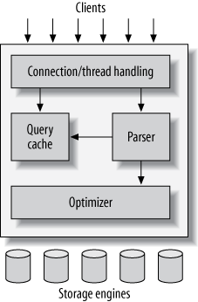

The third layer contains the storage engines. They are responsible for storing and retrieving all data stored “in” MySQL. Like the various filesystems available for GNU/Linux, each storage engine has its own benefits and drawbacks. The server communicates with them through the storage engine API. This interface hides differences between storage engines and makes them largely transparent at the query layer. The API contains a couple of dozen low-level functions that perform operations such as “begin a transaction” or “fetch the row that has this primary

key.” The storage engines don’t parse SQL[[4](https://www.safaribooksonline.com/library/view/high-performance-mysql/9781449332471/ch01.html" \l "ftn.CHP-1-FN-1)] or communicate with each other; they simply respond to requests from the server.

|  |
| --- |
|  |

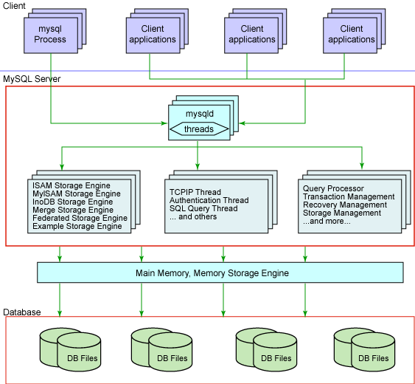

**8.2 Softwares and tools used:**

**8.2.1 My Sql:**

**Introduction:**

The database has become an integral part of almost every human's life. Without it, many things we do would become very tedious, perhaps impossible tasks. Banks, universities, and libraries are three examples of organizations that depend heavily on some sort of database system. On the Internet, search engines, online shopping, and even the website naming convention would be impossible without the use of a database. A database that is implemented and interfaced on a computer is often termed a

database server. One of the fastest SQL (Structured Query Language) database servers currently on the market is the MySQL server, developed by T.c.X. DataKonsultAB. MySQL, available for download at www.mysql.com, offers the database programmer with an array of options and capabilities rarely seen in other database servers. MySQL is free of charge for those wishing to use it for private and commercial use. Those wishing to develop applications specifically using MySQL should consult MySQL's licensing section, as there is charge for licensing the server.

**These capabilities range across a number of topics, including the following:**

a) Ability to handle an unlimited number of simultaneous users.

b) Capacity to handle 50,000,000+ records.

c) Very fast command execution, perhaps the fastest to be found on the market.

d) Easy and efficient user privilege system.

However, perhaps the most interesting characteristic of all is the fact that it's free. That's right, T.c.X offers MySQL as a free product to the general public.

# Reasons to Use MySQL

### a) Scalability and Flexibility

The MySQL database server provides the ultimate in scalability, sporting the capacity to handle deeply embedded applications with a footprint of only 1MB to running massive data warehouses holding terabytes of information. Platform flexibility is a stalwart feature of MySQL with all flavors of Linux, UNIX, and Windows being supported.

### b) High Performance

A unique storage-engine architecture allows database professionals to configure the MySQL database server specifically for particular applications, with the end result being amazing performance results.

**C) High Availability**

Rock-solid reliability and constant availability are hallmarks of MySQL, with customers relying on MySQL to guarantee around-the-clock uptime. MySQL offers a variety of high-availability options from high-speed master/slave replication configurations, to specialized Cluster servers offering instant failover, to third party vendors offering unique high-availability solutions for the MySQL database server.

### d) Robust Transactional Support

MySQL offers one of the most powerful transactional database engines on the market. Features include complete ACID (atomic, consistent, isolated, durable) transaction support, unlimited row-level locking, distributed transaction capability, and multi-version transaction support where readers never block writers and vice-versa.

**e) Web and Data Warehouse Strengths**

MySQL is the de-facto standard for high-traffic web sites because of its high-performance query engine, tremendously fast data inserts capability, and strong support for specialized web functions like fast full text searches.

### f) Strong Data Protection

Because guarding the data assets of corporations is the number one job of database professionals, MySQL offers exceptional security features that ensure absolute data protection. In terms of database authentication, MySQL provides powerful mechanisms for ensuring only authorized users have entry to the database server, with the ability to block users down to the client machine level being possible.

### g) Management Ease

MySQL offers exceptional quick-start capability with the average time from software download to installation completion being less than fifteen minutes. This rule holds true whether the platform is Microsoft Windows, Linux, Macintosh, or UNIX.

# PHP Main Features of MySQL

1. The MySQL Server design is multi-layered with independent modules.
2. Fully multi-threaded using kernel threads. It can easily use multiple CPUs if they are available.
3. Provides transactional and non-transactional storage engines.
4. Uses very fast B-tree disk tables with index compression.
5. Relatively easy to add other storage engines. This is useful if you want to provide an SQL interface for an in-house database.
6. A very fast thread-based memory allocation system.
7. Very fast joins using an optimized one-sweep multi-join.
8. SQL functions are implemented using a highly optimized class library and should be as fast as possible. Usually there is no memory allocation at all after query initialization.
9. The server is available as a separate program for use in a client/server networked environment.

**8.2.2 WAMP:-**

### Install WAMP by double clicking on the icon, an installation wizard will be opened.

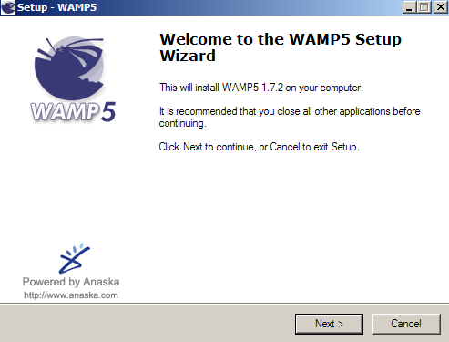

## b) Click on next button to continue , and then again box will be appeared on the screen asking you for acceptance or not acceptance of the license agreement.

## c) For this select option “I accept the terms in the license agreement”. Click on next button.

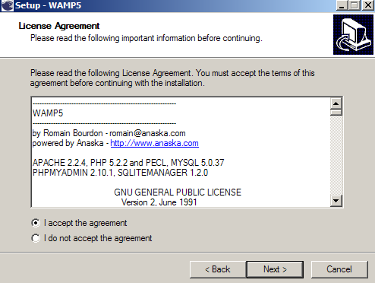

**d) Then again wizard will be opened asking you about the location of placing the folder. For selecting location click on browse and click next.**

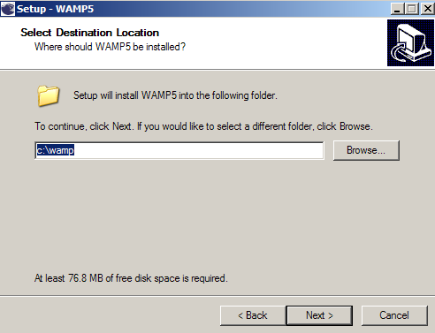

**e) The next wizard will ask you about auto start the WAMP i.e. if you want to start the WAMP automatically then click on the checkbox and if do not want then it remain unchecked.**

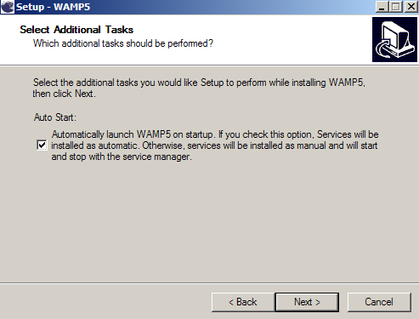

**f) Click on next button to precede further, the next wizard will display you the summary of the setting . Click on install button for installation.**

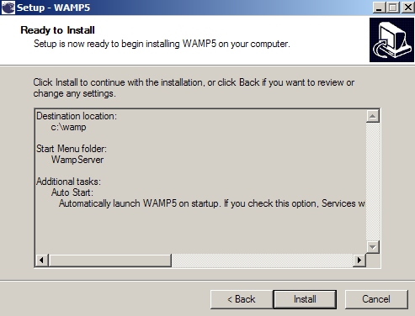

**g) After installation the next wizard will be opened asking you about directory for your root folder .if you are not sure , just leave the default directory .for proceeding further click on next button.**

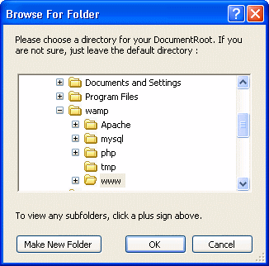

1. **The next wizard will ask you about your server just fill localhost and click on next button.**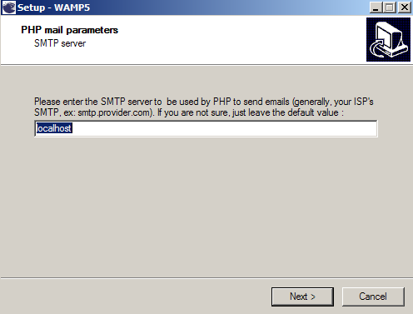
2. **This wizard will ask you about the browser by default browser is internet explorer you can set default browser according to your requirement .click on next button.**

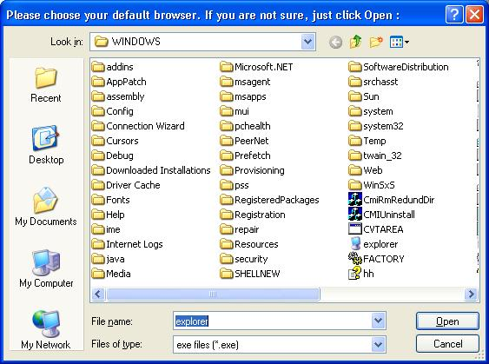

1. **On clicking next a popup menu will displayed asking you “would you like to install the new WAMP homepage ?” click on yes option.**

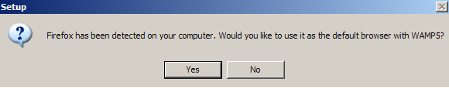

1. **Finally click on finish after complete installation of WAMP on your system.**

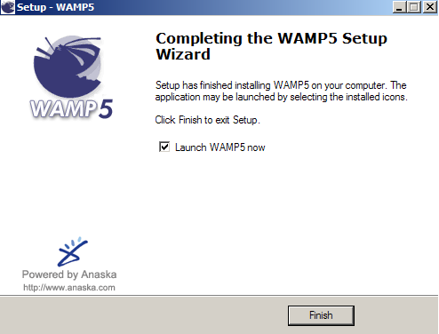

**9. SOFTWARE DEVELOPMENT PROCESS**

Systems Development Life Cycle (SDLC), or *Software Development Life Cycle*, in systems engineering and software engineering relates to the process of developing systems, and the models and methodologies, that people use to develop these systems, generally computer or information systems.

In software engineering this SDLC concept is developed into all kinds of software development methodologies, the framework that is used to structure, plan, and control the process of developing an information system, the software development process.

**9.1 Overview**

Systems Development Life Cycle (SDLC) is any logical process used by a systems analyst to develop an information system, including requirements, validation, training, and user ownership. An SDLC should result in a high quality system that meets or exceeds customer expectations, within time and cost estimates, works effectively and efficiently in the current and planned Information Technology infrastructure, and is cheap to maintain and cost-effective to enhance.

Computer systems have become more complex and usually (especially with the advent of Service-Oriented Architecture) link multiple traditional systems often supplied by different software vendors. To manage this, a number of system development life cycle (SDLC) models have been created: waterfall, fountain, spiral, build and fix, rapid prototyping, incremental, and synchronize and stabilize. Although in the academic sense, SDLC can be used to refer to various models, SDLC is typically used to refer to a waterfall methodology.

In project management a project has both a life cycle and a "systems development life cycle" during which a number of typical activities occur. The project life cycle (PLC) encompasses all the activities of the project, while the systems development life cycle (SDLC) is focused on accomplishing the product requirements.

**9.2 Systems Development Phases**

Systems Development Life Cycle (SDLC) adheres to important phases that are essential for developers, such as planning, analysis, design, and implementation, and are explained in the section below. There are several Systems Development Life Cycle Models in existence. The oldest model, that was originally regarded as "the Systems Development Life Cycle" is the waterfall model: a sequence of stages in which the output of each stage becomes the input for the next. These stages generally follow the same basic steps but many different waterfall methodologies give the steps different names and the number of steps seems to vary between 4 and 7. There is no definitively correct Systems Development Life Cycle model, but t he steps can be characterized and divided in several steps.

**9.2.1 FEASIBILTY CONSIDERATIONS**

A feasibility study is a test of a system proposal according to its workability impact on organization, ability to meet user needs and effective use of resources. The objective of a feasibility study is not to solve a problem but to acquire a sense of its scope. During the study, the problem definition is crystallized and the aspects of the problem to be included in the system are determined. After the initial investigation of the system that helped to have in-depth study of the existing system, understanding its strength and weaknesses and the requirements for the new proposed system.

Feasibility study was done in three phases documented below.

**9.2.1.1 Economic Feasibility:**

Economic analysis is the most frequently used method for evaluating the effectiveness of a candidate system.

This procedure is used to determine the benefits and savings that are expected from candidate system and compare them with the cost.

If the benefits outweigh the cost, then the decision is made to design and implements the system.

**9.2.1.2 Technical Feasibility:**

Technical feasibility centers on the exiting computer system and to what extent it can support the proposed addition.

We have to keep in mind the capacity of the proposed system and make an effort not to over load the system.

This may require technical enhancement and these may further require financial considerations to support the enhancements, if the budget is a serious constraint then the project is judge as not feasible.

**9.2.1.3 Behavioral Feasibility:**

Peoples are naturally accepting to change a computers are known to make possible change.

An estimate should be made of how strong the reactions of the user staff are likely to have toward the development of a computerized system.

**9.2.2 ANALYSIS PHASE**

**Existing System Details and Problems**

1. It was difficult to set the JDK information on the system in the mean time. Moreover it was a time consuming affair if a person is new to start working with java.
2. It was difficult to solve the problems those were arising during a particular installation of the software because of hardware compatibility issues.
3. Moreover there is usage an issue concerned with the software .This issue has been resolved by the WEB-IDE by providing Integrated Environment facility to its users.
4. This system provides the feature of uploading a java file already on the local machine of the user or he can make altogether a new java program using this IDE and save it on his local machine also.

**9.2.2.1 User Requirements**

Since end users are the ones who are finally going to use the system, their requirements need to be identified. This involves questioning the end users what their expectations were.

The main requirement of the end user is that the system should be easy to use and take less time. In addition to these another important factor was to eliminate the need for database conversion and migration that had to be carried out presently. After conducting interviews with the users a document called the software requirement specification was created. This is the most important document that forms the basis for system development. It should be consistent, complete, unambiguous, traceable and inter-related.

This document has the following components.

1. **Functional Requirements:**The functional requirements specify relationship between the inputs and outputs. All the operations to be performed on the input data to obtain output are to be specified. This includes specifying the validity checks on the input and output data, parameters affected by the operations and the other operations, which must be used to transform the inputs into outputs. Functional requirements specify the behavior of the system for valid input and outputs.
2. **Performance Requirements:**This section includes performance of the product that are set by user interaction and studying the existing system of the organization. These are stated in complete measurable terms, so that they can be verified during system evaluation phase. Some of the performance requirements are stated below.
3. **User Friendly:** The system produced is user friendly, understandable and easy to use so that the users of the system can easily learn to use the system. For this the system is made menu-driven with well-documented programs.
4. **Time Element (response and processing time):** The response time of the system is very less and takes less time to execute queries and triggers.
5. **Maximum Throughput:** the system gives maximum throughput with relevant output
6. **Robustness:** the system will be able to handle undesirable situations and errors encountered at various levels e.g. if the user supplies invalid input for processing, the system gracefully halts, displaying a message to the user indicating the cause of the error and prompting him it enter the correct input.
7. **Flexibility:** the system is flexible in nature so that likely changes and alterations can easily be made.
8. **Information Security:** records in the system must be safe, confidential and must be prevented from unauthorized access.
9. **Moral and User Satisfaction:** system will be able to satisfy the user requirements; this is the main and conspicuous measure of the system performance. Also the system must raise the moral of the user. The higher the moral, greater the expected work performance level.

**9.2.2.2 External Interfaces and Data Flow**

This heading specifies the externally observable characteristics of the software product. Several graphical tools are used to express the requirements of a system rather than writing long lines of text. These are very effective tools for use during the system analysis phase.

**User Displays:** These are extremely useful tools for interactive applications where fast response is needed. The user displays consist of screens that help in designing a menu driven system. The menus attached to the screens help in making a system interactive and user friendly by providing an easy to use point and click interface to the application. These menus consist of a list of options from which the user can choose an action depending on the task to be performed. So these forms or so called user displays is the key to the success of the entire system.

**9.2.2.3 Development, Operation and Maintenance Environments**

1. **Development Environment**

Having constant interaction with the users as well as management aids in the system development. The logical user suggestions sure certainly welcomed and considered. There is a multi-user environment in the organization. For the development of new system Microsoft SQL Server, rdbms package, tomcat server for server side programming will be used and Microsoft front page, java server pages and java script for client side programming and will be used to provide GUI to system.

1. **Operating Environment**

The input data required are obtained from the documents, which contains all the details of the transactions. After validation and relevant processing, the data is to be stored in the database. The user selects the desired database table on after which the query is formulated. The query is generated by filtering the database based on the user defined conditions and constraints. The formulated query is executed on the database to obtain the required information.

1. **Maintenance Environment**

The proper maintenance of the new system is very important for its smooth working. The maintenance of the software is to be done by the system analyst and programmers in the organization. But for hardware maintenance engineer may be called from where hardware was purchased.

**9.2.2.4 User Characteristics**

The users of the new system will be the users of the website of the organization. The system is developed with the participation of users, which will help them to understand the system easily.

**Sources of Information**

Primary sources of the information involve direct interaction with the employees of the organization working in the development department.

The various techniques used for collecting information are:

1. **Interviews**: Interviews are the main source of gathering data and to get acquainted with the existing system. Almost all the information about the present system was gathered with the help of interviews. The questions are pre-planned and asked according to the designation of the users.
2. **Observations**: Observations were personally made of what data is desired and how it is to be graphically represented or in a tabular manner and how it is to be saved. The observation of crucial information, data flows and functioning of the entire system was made carefully. This helped to obtain the additional knowledge about the system and to view the system more deeply. So all the aspects of the existing system are thoroughly observed which includes how people perform their tasks, noting the things that they do, how they do it and how much time they take. The records being manipulated and their frequency of updating and flow of documentation and important business transactions are also observed. Observations were personally made of how data can be possibly queried and represented by the user.

**9.2.2.5 System Outline View**

After firming the requirements of the system, the summary chart or data flow diagram (DFD) of the proposed system is prepared. This gives the brief of the system with respect to the inputs being considered, the outputs reports, the data being transformed and the main processed involved in the system.

**9.2.3 Design Phase**

During this phase, the system is designed to satisfy the functional requirements identified in the previous phase. Since problems in the design phase could be very expensive to solve in the later stage of the software development, a variety of elements are considered in the design to mitigate risk. These include:

1. Identifying potential risks and defining mitigating design features.
2. Performing a security risk assessment.
3. Developing a conversion plan to migrate current data to the new system.
4. Determining the operating environment.
5. Defining major subsystems and their inputs and outputs.
6. Allocating processes to resources.
7. Preparing detailed logic specifications for each software module.

**9.2.4 Development Phase**

Effective completion of the previous stages is a key factor in the success of the Development phase. The Development phase consists of:

1. Translating the detailed requirements and design into system components.
2. Testing individual elements (units) for usability.
3. Preparing for integration and testing of the IT system.

**9.2.5 Integration and Test Phase**

Subsystem integration, system, security, and user acceptance testing is conducted during the integration and test phase. The user, with those responsible for quality assurance, validates that the functional requirements, as defined in the functional requirements document, are satisfied by the developed or modified system. OIT Security staff assesses the system security and issue a security certification and accreditation prior to installation/implementation. Multiple levels of testing are performed, including:

1. Testing at the development facility by the contractor and possibly supported by end users
2. Testing as a deployed system with end users working together with contract personnel
3. Operational testing by the end user alone performing all functions.

**9.2.6 Implementation Phase**

This phase is initiated after the system has been tested and accepted by the user. In this phase, the system is installed to support the intended business functions. System performance is compared to performance objectives established during the planning phase. Implementation includes user notification, user training, installation of hardware, installation of software onto production computers, and integration of the system into daily work processes.

This phase continues until the system is operating in production in accordance with the defined user requirements.

**9.2.7 Operations and Maintenance Phase**

The system operation is ongoing. The system is monitored for continued performance in accordance with user requirements and needed system modifications are incorporated. Operations continue as long as the system can be effectively adapted to respond to the organization’s needs. When modifications or changes are identified, the system may reenter the planning phase. The purpose of this phase is to:

1. Operate, maintain, and enhance the system.
2. Certify that the system can process sensitive information.
3. Conduct periodic assessments of the system to ensure the functional requirements continue to be satisfied.
4. Determine when the system needs to be modernized, replaced, or retired.

**9.2.8 Disposition Phase**

Disposition activities ensure the orderly termination of the system and preserve the vital information about the system so that some or all of the information may be reactivated in the future if necessary. Particular emphasis is given to proper preservation of the data processed by the system, so that the data can be effectively migrated to another system or archived for potential future access in accordance with applicable records management regulations and policies. Each system should have an interface control document defining inputs and outputs and data exchange. Signatures should be required to verify that all dependent users and impacted systems are aware of disposition.

**9.3 SDLC OBJECTIVES**

**The objectives of the SDLC approach are to:**

1. Deliver quality systems which meet or exceed customer expectations when promised and within cost estimates
2. Develop quality systems using an identifiable, measurable, and repeatable process.
3. Establish an organizational and project management structure with appropriate levels of authority to ensure that each system development project is effectively managed throughout its life cycle.
4. Identify and assign the roles and responsibilities of all affected parties including functional and technical managers throughout the system development life cycle.
5. Ensure that system development requirements are well defined and subsequently satisfied.
6. Provide visibility to the State of Maryland functional and technical managers for major system development resource requirements and expenditures.
7. Establish appropriate levels of management authority to provide timely direction, coordination, control, review, and approval of the system development project.
8. Ensure project management accountability.
9. Ensure that projects are developed within the current and planned information technology infrastructure.
10. Identify project risks early and manage them before they become problems.

**9.4 SYSTEM STUDY & PROBLEM FORMULATION**

A Software Requirements Specification (SRS) is a complete description of the behavior of the software of the system to be developed. It includes a set of use cases that describe all the interactions the users will have with the software. Use cases are also known as functional requirements. In addition to use cases, the SRS also contains nonfunctional (or supplementary) requirements. Non-functional requirements are requirements which impose constraints on the design or implementation (such as performance engineering requirements, quality standards, or design constraints).

**9.4.1** **Purpose**

The purpose of this software requirements specification (SRS) is to establish the ten major requirements necessary to develop the Software Systems Engineering.

**9.5 Test Plans**

Project Testing is an investigation conducted to determine the quality of the project and the services provided by the project. Testing is the process of analyzing a project to detect the differences between existing and required conditions (i.e defects/errors/bugs)and to evaluate the features of the project .

After complete development of the project it is mandatory to test the project. The main motive of the project testing is to identify whether project is able to meet user requirements or not. To know the better performance of project we have to develop various test cases. Now, designing good test cases is a complex art..The complexity comes from three sources:

Test cases help us discover information. Different types of tests are more effective for different classes of information.

Test cases can be “good” in a variety of ways .No test case will be good in all of them.

Tend to create test cases according to certain testing styles, such as domain testing or risk-based testing .Good domain tests are different from good risk-based tests.

Testing Objectives:

The main objective of testing is to uncover a host of errors, systematically and with minimum effort and time. Stating formally, we can say, Testing is a process of executing a program with the intent of finding an error.

A successful test is one that uncovers an as yet undiscovered error. The tests are inadequate to detect possibly present errors. The software more or less confirms to the quality and reliable standards.

The most important activity at the implementation stage is the system testing with the objective of validating the system against the designed criteria. During the development cycle, user was involved in all the phases that are analysis, design and coding. After each phase the user was asked whether he was satisfied with the output and the desired rectification was done at the moment. During coding, generally bottom up technique is used. Firstly the lower level modules are coded and then they are integrated together. Thus before implementation, it involves the testing of the system. The testing phase involves testing first of separate parts of the system and then finally of the system as a whole. Each independent module is tested first and then the complete system is tested. This is the most important phase of the system development. The user carries out this testing and test data is also prepared by the user to check for all possible combinations of correct data as well as the wrong data that is trapped by the system. So the testing phase consists of the following steps:

**9.5.1 Unit Testing:**

The purpose of the coding and unit testing phase of software development is to translate the software design into source code. Each component of the design is implemented as a program module. The end-product of this phase is a set of program modules that have been individually tested. To enable the engineers to write good quality programs, every software development organization normally formulates its own coding standards that suit itself. A coding standard addresses issues such as the standard ways of laying out the program codes, the template for laying out the function and module headers, commenting guidelines, variable and function naming conventions, the maximum number of source lines permitted in each module, and so forth.

During this phase, each module is unit tested to determine the correct working of all the individual modules. It involves testing each module in isolation as this is the most efficient way to debug the errors identified at this stage. Another reason behind testing a module in isolation is that the other modules, with which this module has to be interfaced, may not be ready.

**9.5.2 Integration and System Testing:**

Integration of different modules is undertaken once they have been coded and unit tested. During the integration and system testing phase, the modules are integrated in a planned manner. The different modules making up a software product are almost never integrated in one shot. Integration is normally carried out incrementally over a number of steps. During each integration step, the partially integrated system is tested and a set of previously planned modules are added to it. Finally, when all the modules have been successfully integrated and tested, system testing is carried out. The goal of system testing is to ensure that the developed system conforms to its requirements laid out in the SRS document.

Our project is

integrated and tested by using an activity by name ∝- testing. ∝- testing is the system testing performed by the development team.

**9.5.3 Acceptance Testing:**

Acceptance testing is often done by the customer to ensure that the delivered product meets the requirements and works as the customer expected. It falls under the class of black box testing.

**9.5.4 Regression Testing:**

Regression testing is the testing after modification of a system, component, or a group of related units to ensure that the modification is working correctly and is not damaging or imposing other modules to produce unexpected results. It falls under the class of black box testing.

**9.5.5 Beta Testing:**

Beta testing is the testing which is done by end users, a team outside development, or publicly releasing full pre-version of the product which is known as beta version. The aim of beta testing is to cover unexpected errors. It fal

ls under the class of black box testing.

**10.Module Description**

Time Table Generator is a web based application which guides you about tour places. This project includes mainly two modules i.e. login and main page.

**Login:**

1. Admin
2. Student
3. Staff

**Admin:** The page require user id and password to start the application. Login is a process by which individual access to a computer system is controlled by identifying and authenticating the user through the cardinalities presented by the user. Admin can add or delete the category, subcategory etc.

**Student:** Student can register the account by clicking on new register. He/she can add the account for the various Courses. The student have to login to get more information about the time schedule.

**Staff:** Staff can register by admin. The staff have to login to get more information about the time schedule.

**11. Data Flow Diagram(DFD)**

A data flow diagram(DFD) is a graphical representation of the flow of data.The purpose of DFD is to clarify system requirements and identify major transformations that will become program in system design. So it is the starting point of the design phase that functionally decomposes the requirements specifications to the lowest level in detail. These diagrams help to understand the basic working of the system. It helps to make and recognize various parts and their inter relationships. It is a way of expressing system requirements in a graphical form, this leads to a modular design. It is also known as bubble char. A DFD consists of series of bubbles joined by lines. The bubbles represent data transformation and the lines represent data flow in the system.

**DFD Symbols:**

Defines the Souce or Destination of data

Identifies Data Flow

Represents a Process that transforms data flow

Represent data Store

**DFD Of Time Table Generator**

Staff

Student

Admin

Database

**1. ER Diagram**

Entity relationship model defines the conceptual view of database. It works around real world entity and association among them. At view level, ER model is considered well for designing databases.

**Entity Set:** An entity set is a collection of similar types of entities. Entity set may contain entities with attribute sharing similar values. For example, Students set may contain all the student of a school; likewise Teachers set may contain all the teachers of school from all faculties. Entities sets need not to be disjoint.

**Attributes:** Entities are represented by means of their properties, called attributes. All attributes have values. For example, a student entity may have name, class, age as attributes.

**E-R Diagram Symbols**

|  |  |  |  |
| --- | --- | --- | --- |
|  | Represent Entity |  | Represent weak Entity |
|  | Represent attribute |  | Represent weak attribute |
|  | Represent relationship |  | Weak relationship |

**Database Design:**

A database design is a collection of stored data organized in such a way that the data requirements are satisfied by the database. The general objective is to make information access easy, quick, inexpensive and flexible for the user. There are some specific objectives like controlled redundancy from failure, privacy, security and performance. A collection of relative records make up a table. To design and store data to the needed database tables are prepared. One essential setting for a database is:

**Primary Key:** The field that is unique for all the record occurances.

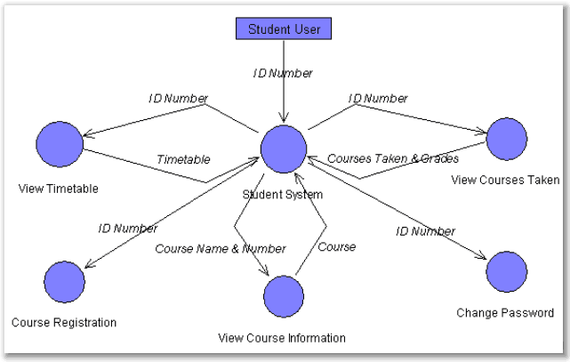

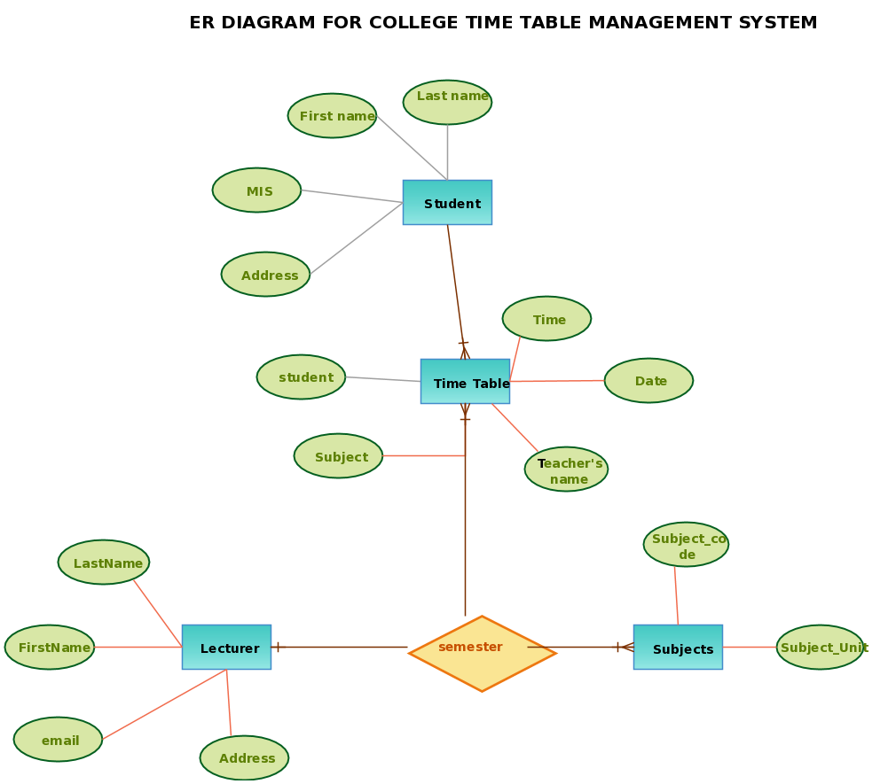

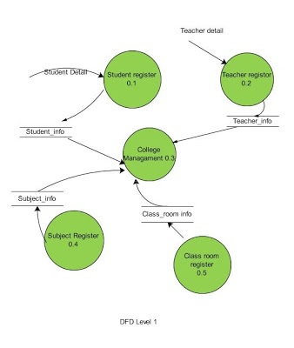

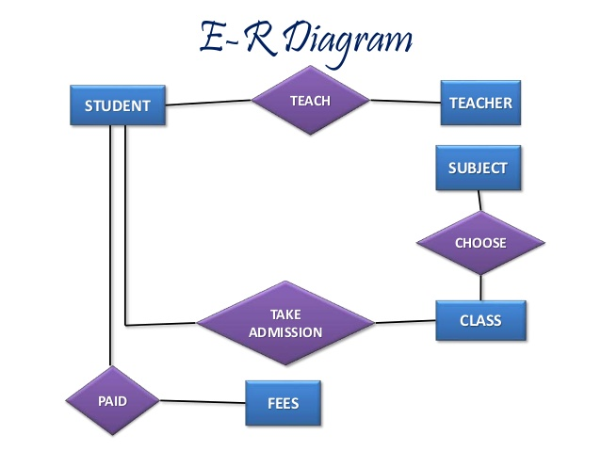

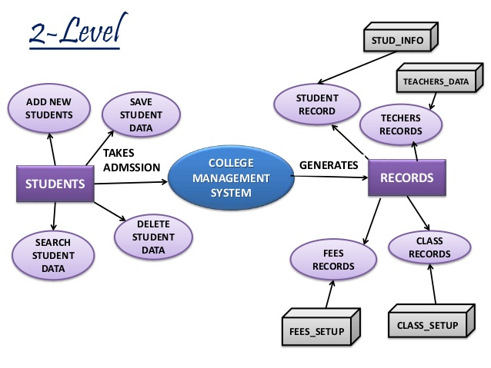

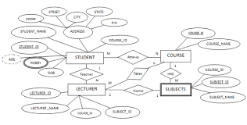

**12.Screenshots of Time Table Generator**

**User Panel**

**Home Page:** This is the Main Page of the project ‘Time Table Generator’.

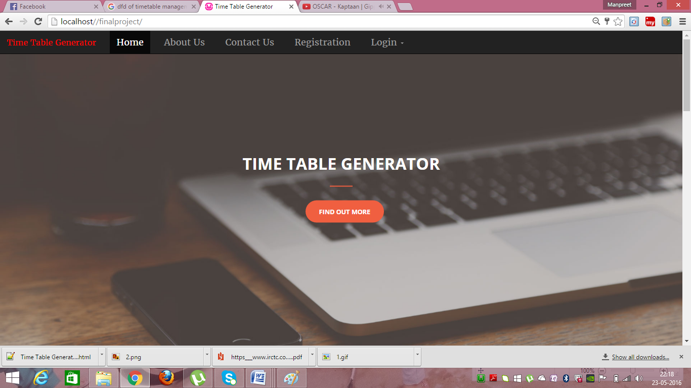

**About Us Page:**

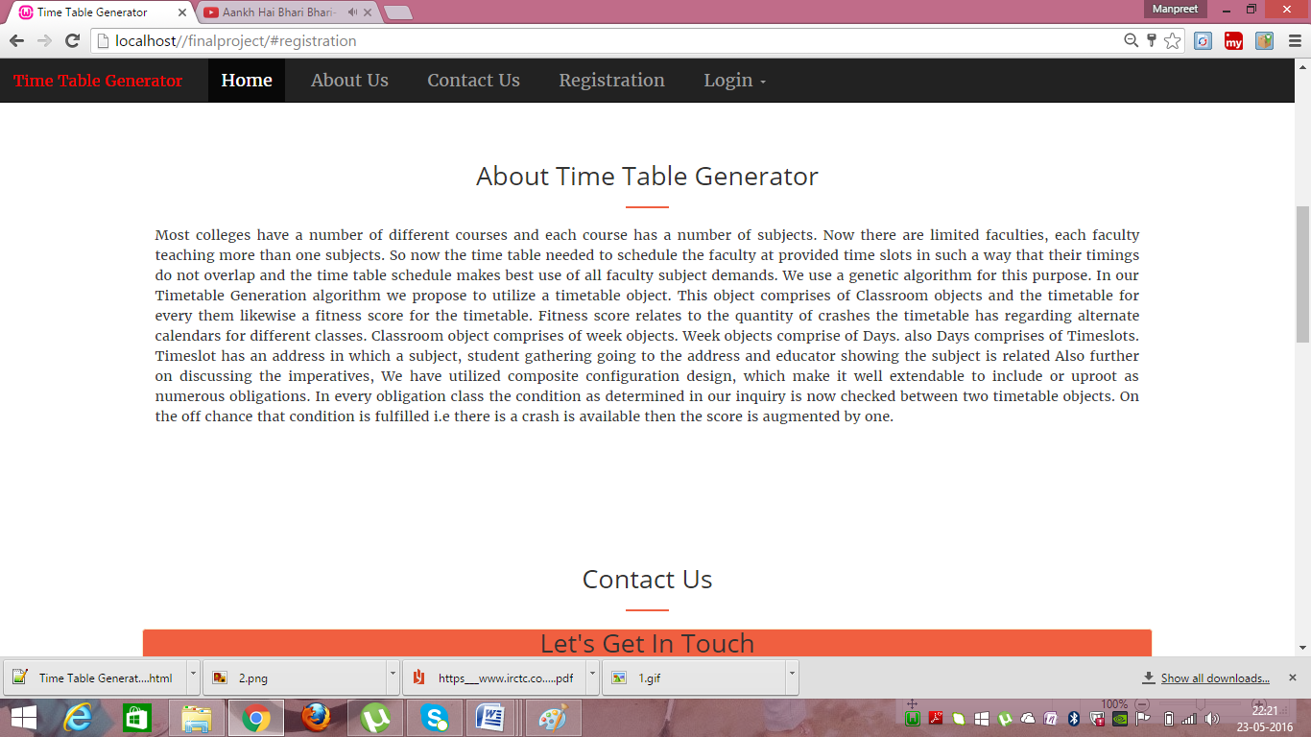

**Contact Us Page:**

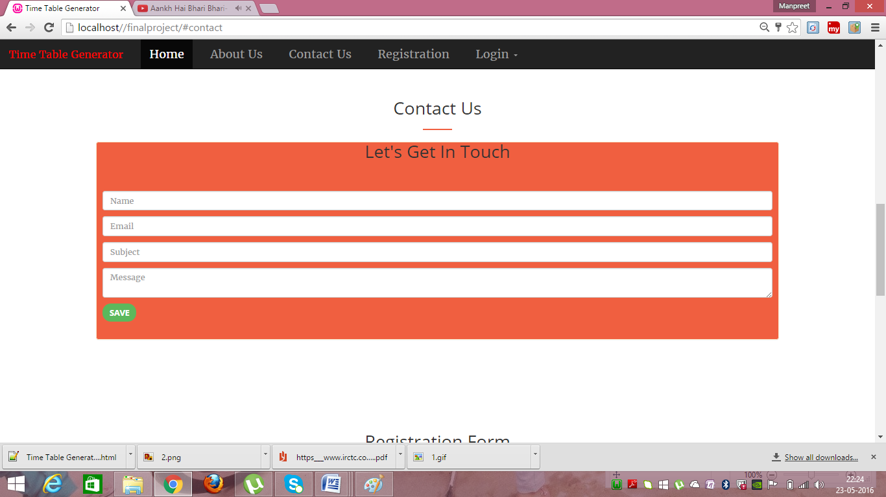

**4.Registration Form:**

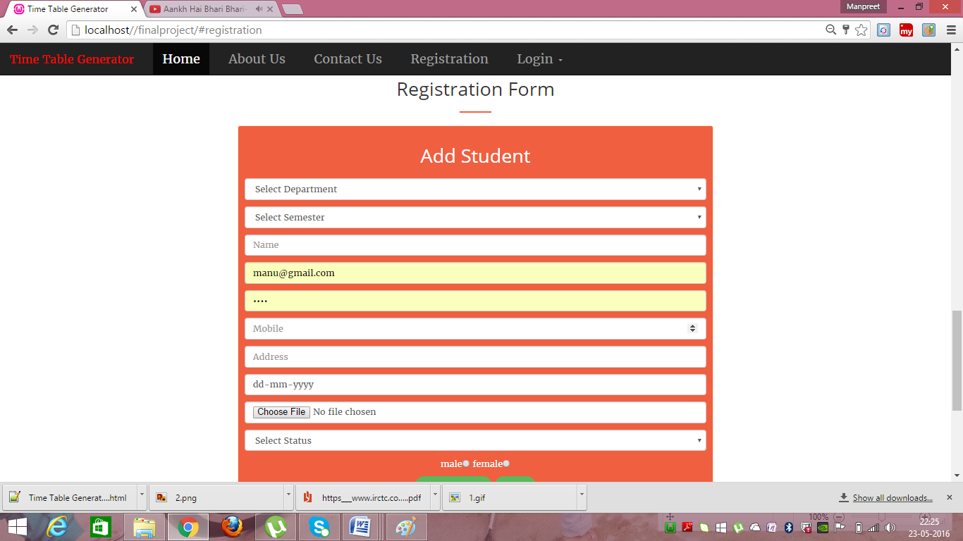

**Staff Login Page:**

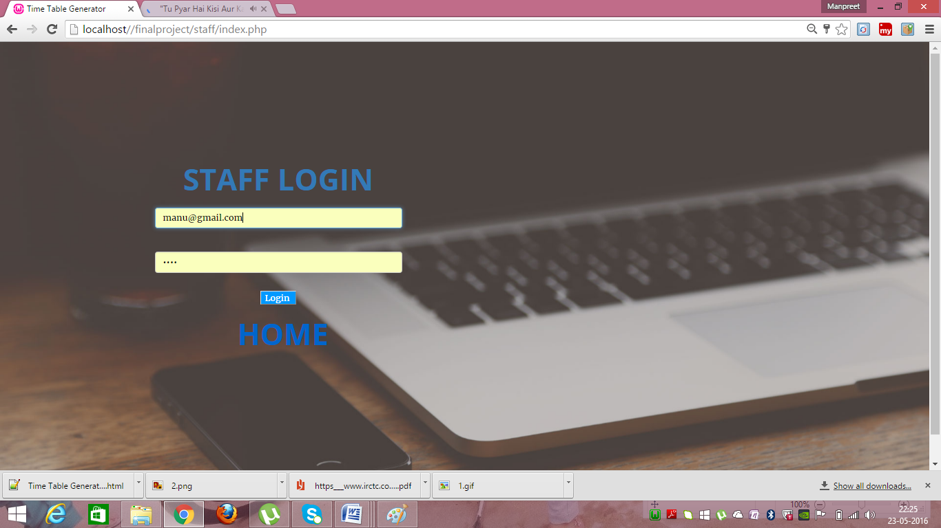

**Student Login Page:**

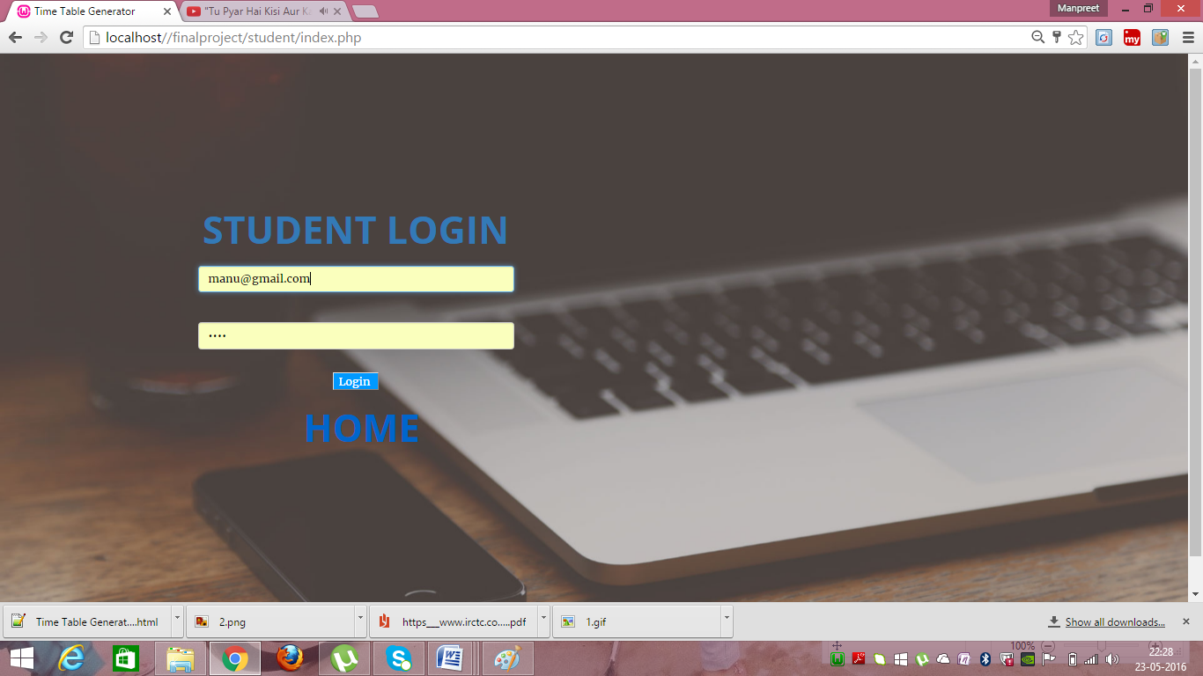

**Teacher Panel:**



**Timeschedule of Teacher:**

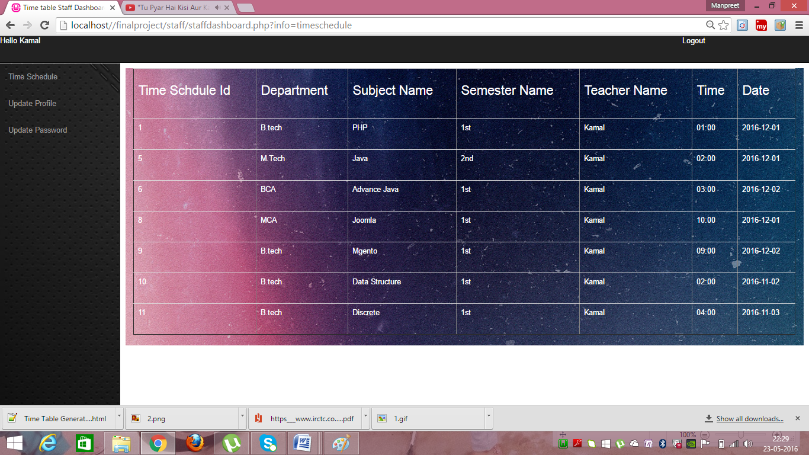

**Update Profile:**

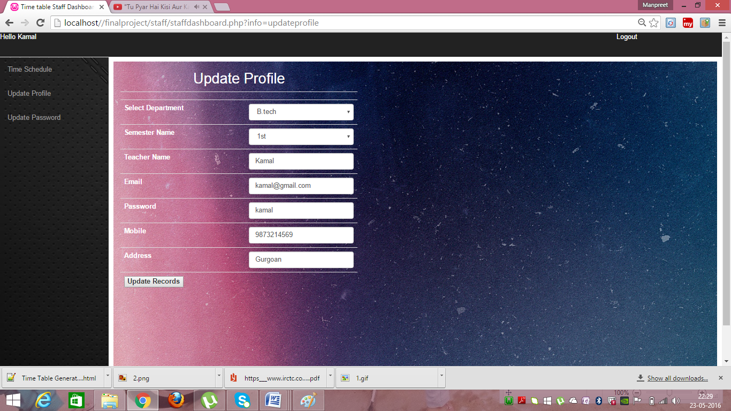

**Update Password:**

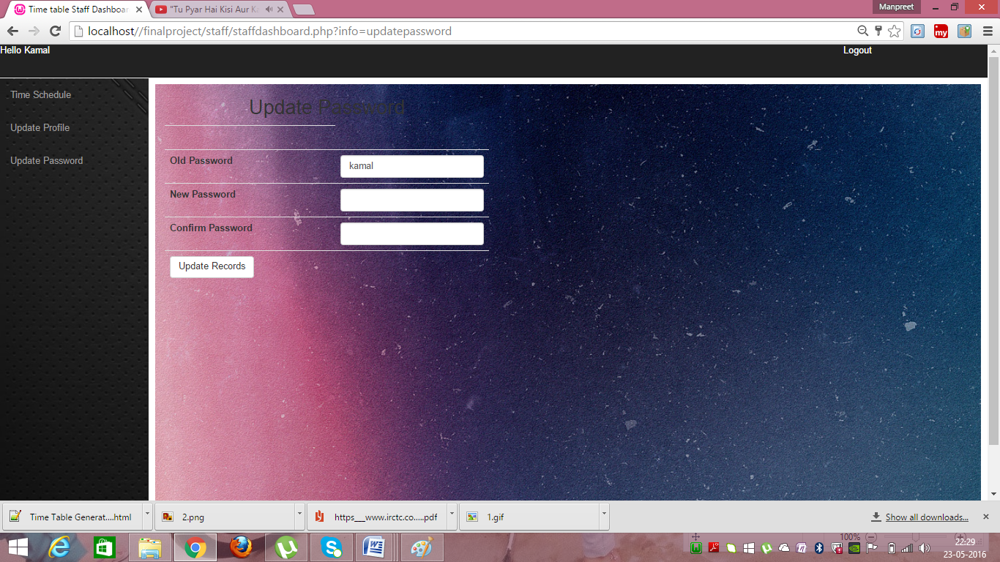

**Student Panel:**

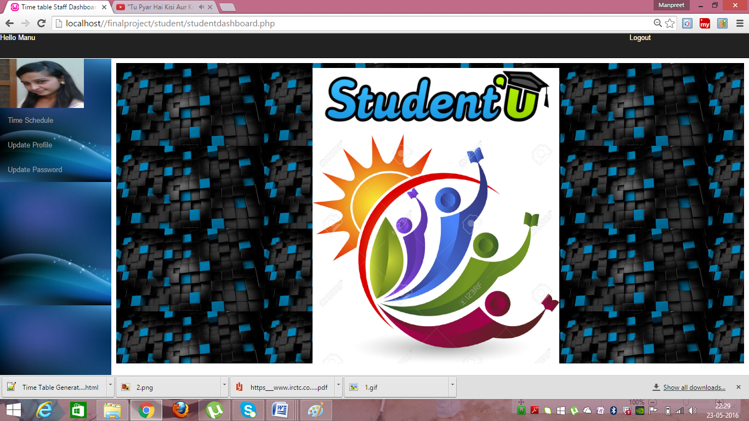

**Timeschedule of Student Panel:**

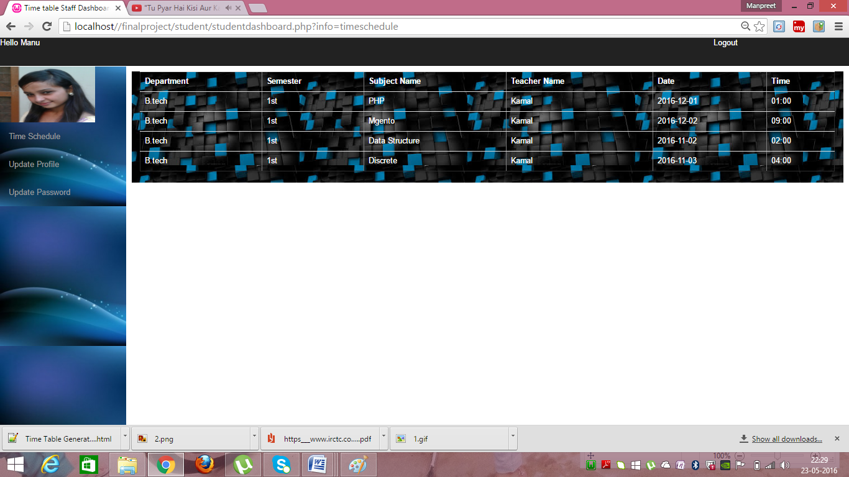

**Update Student Profile:**

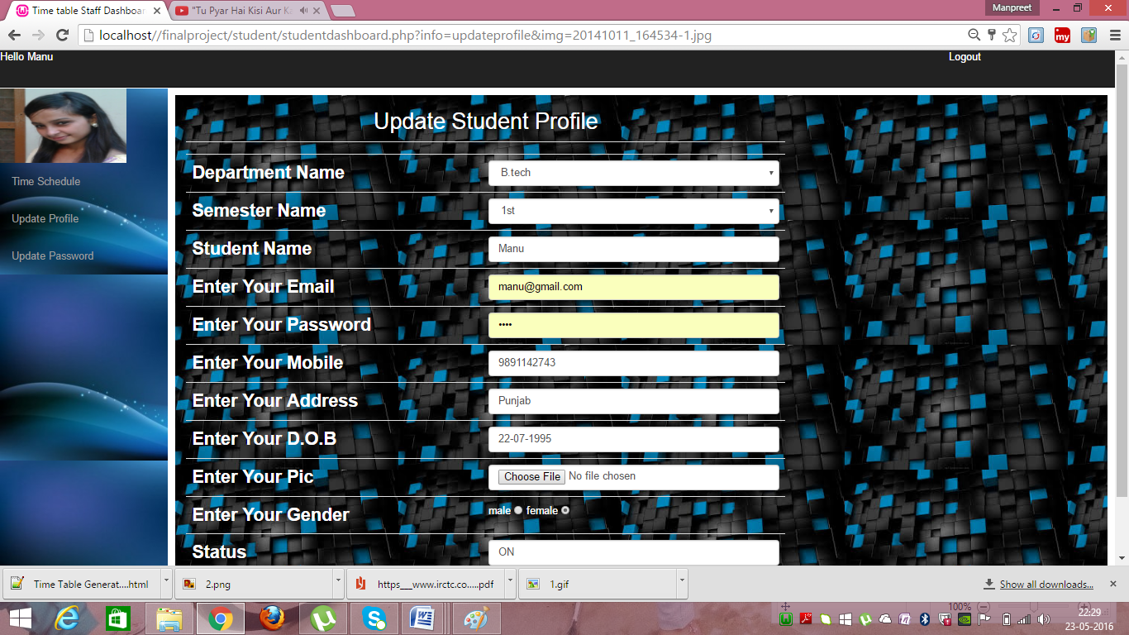

**Update Password:**

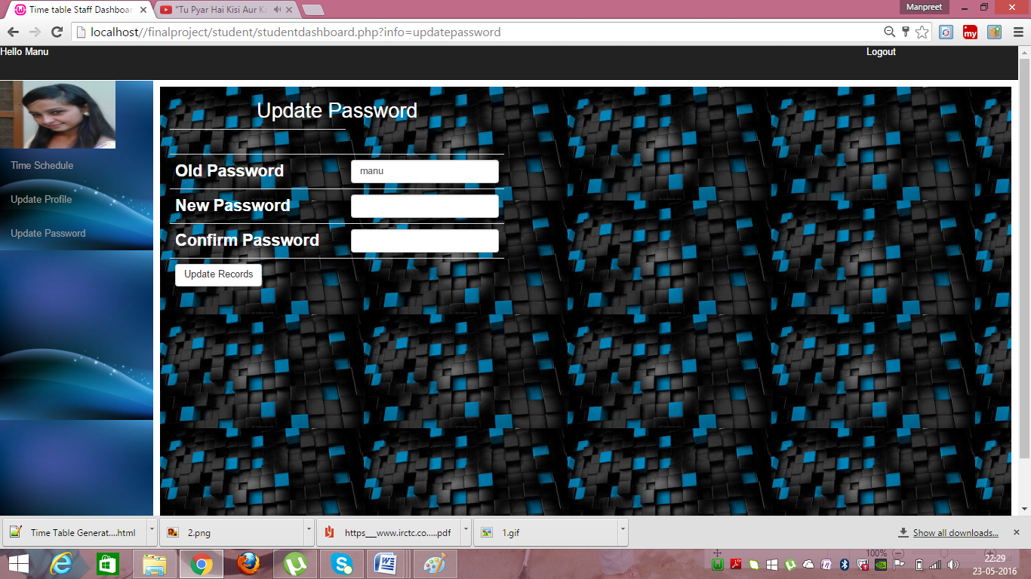

**Admin Login:**

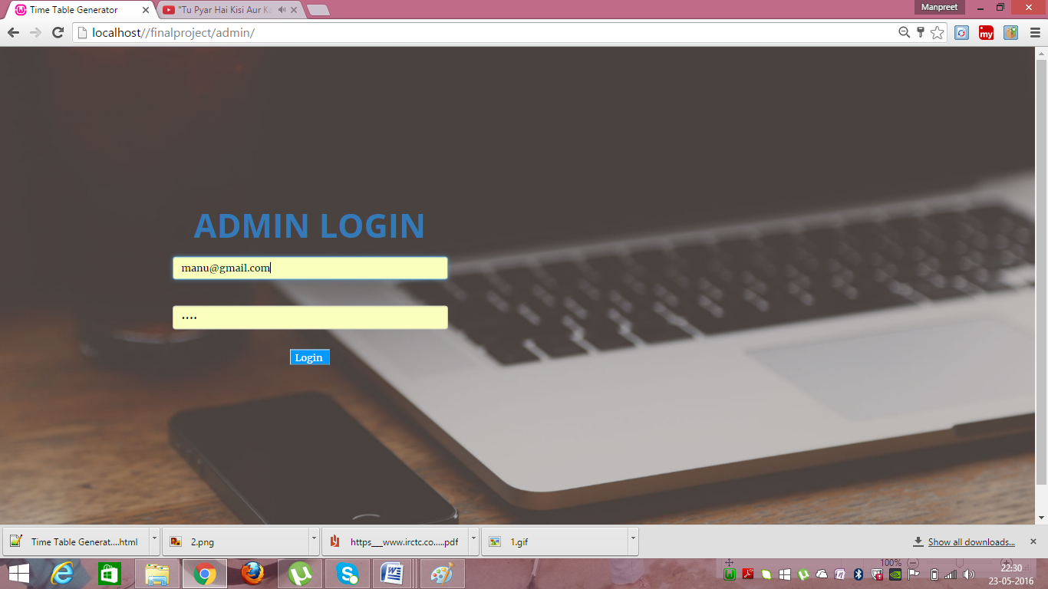

**Admin Panel:**

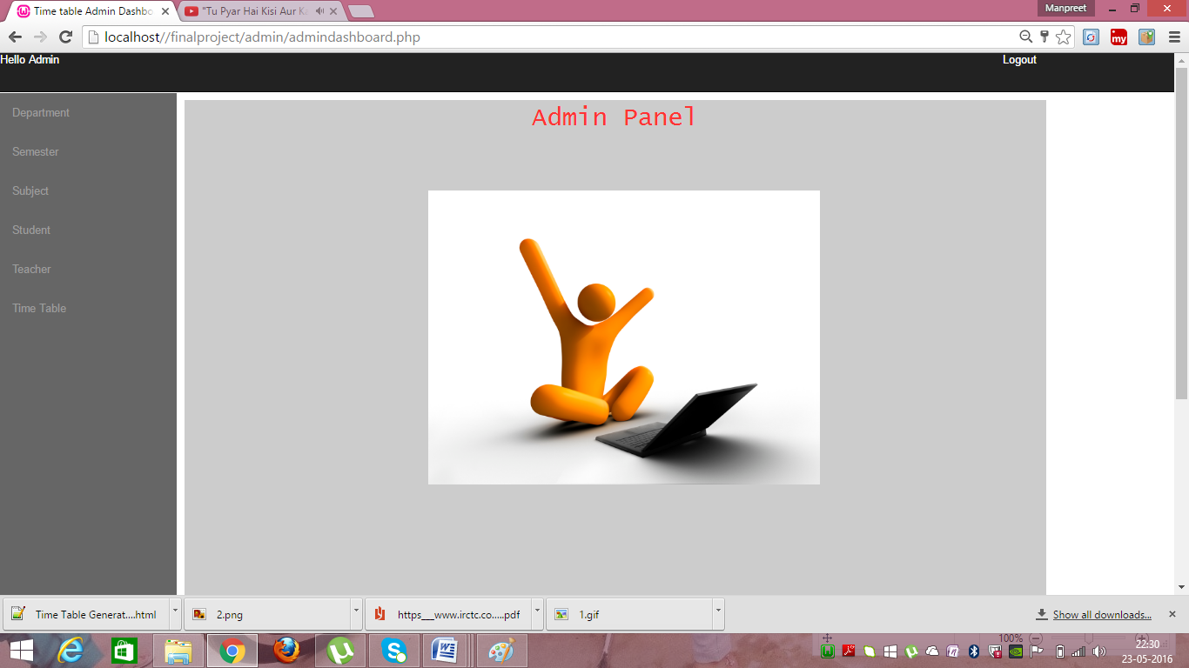

**Departments:**

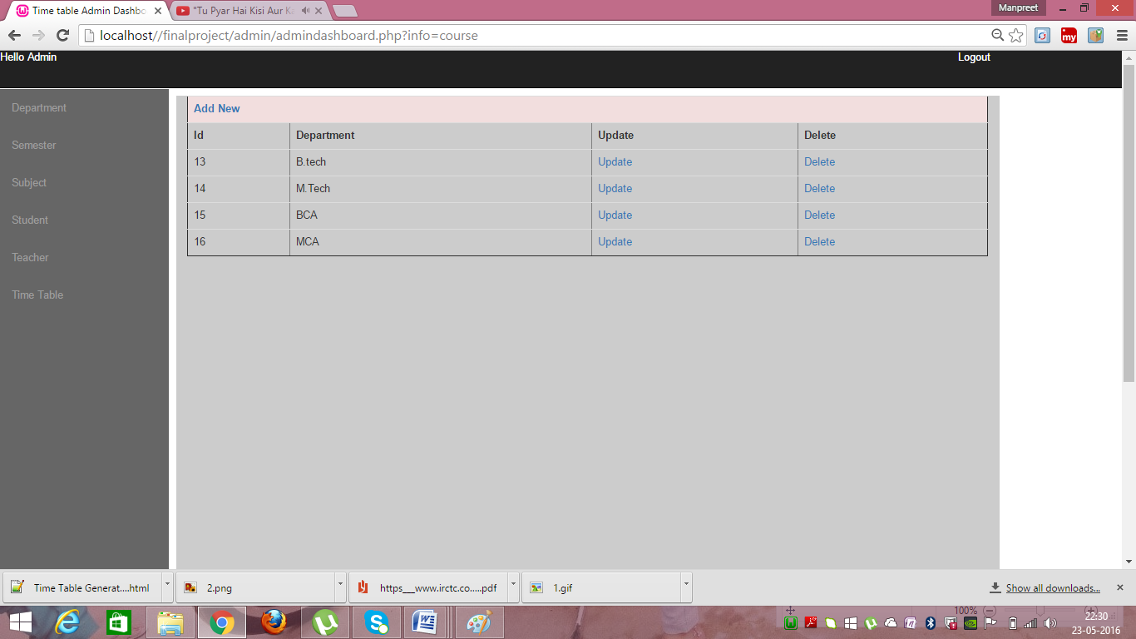

**Semesters:**

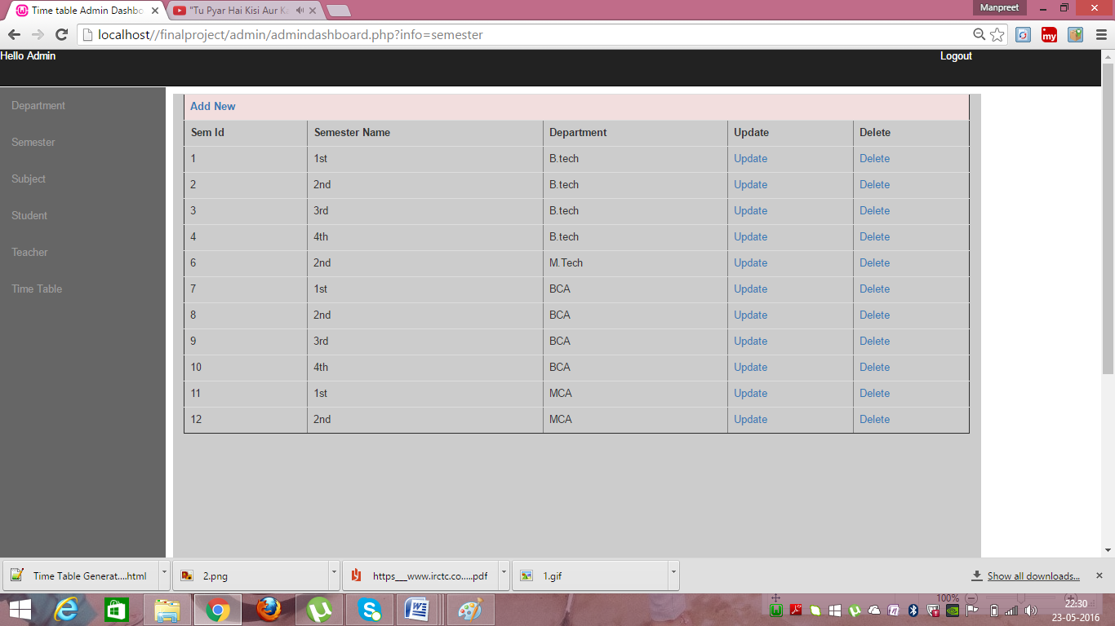

**Subjects:**

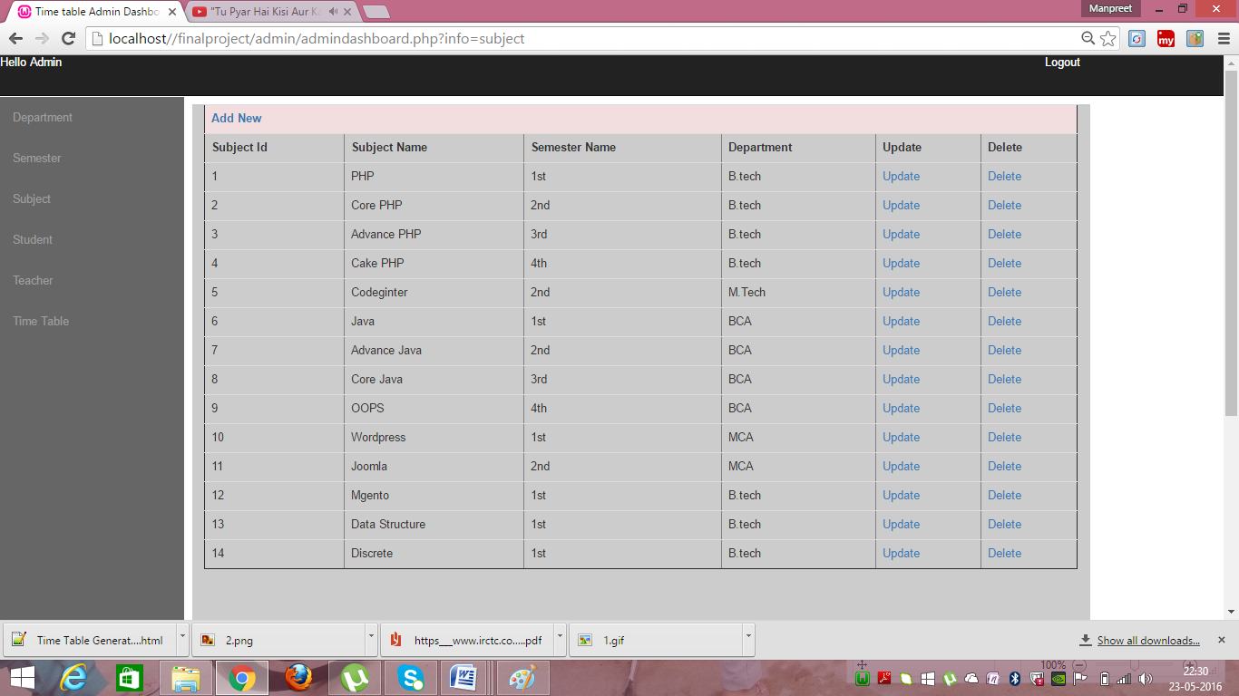

**Students:**

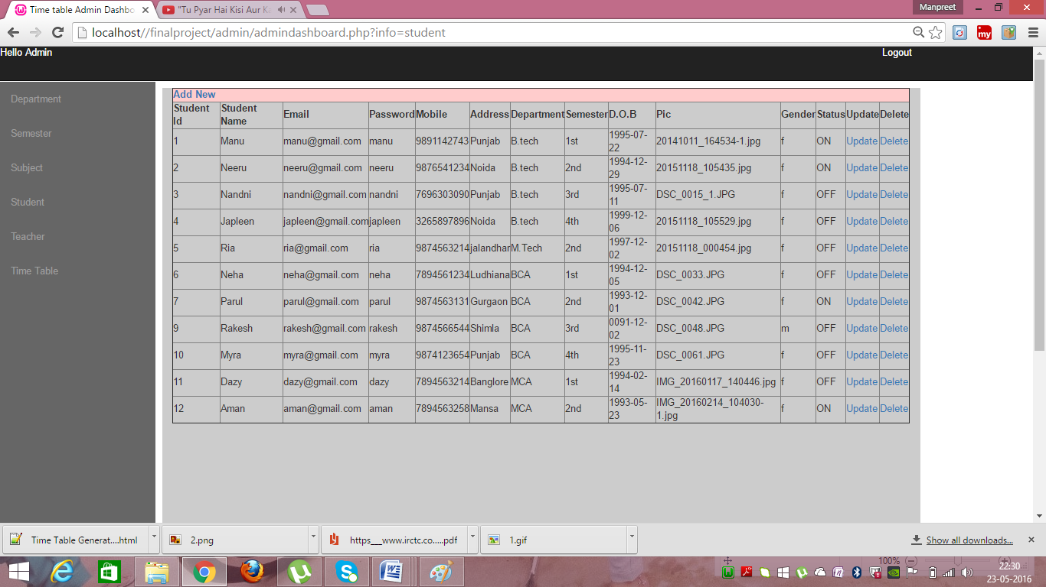

**Teachers:**

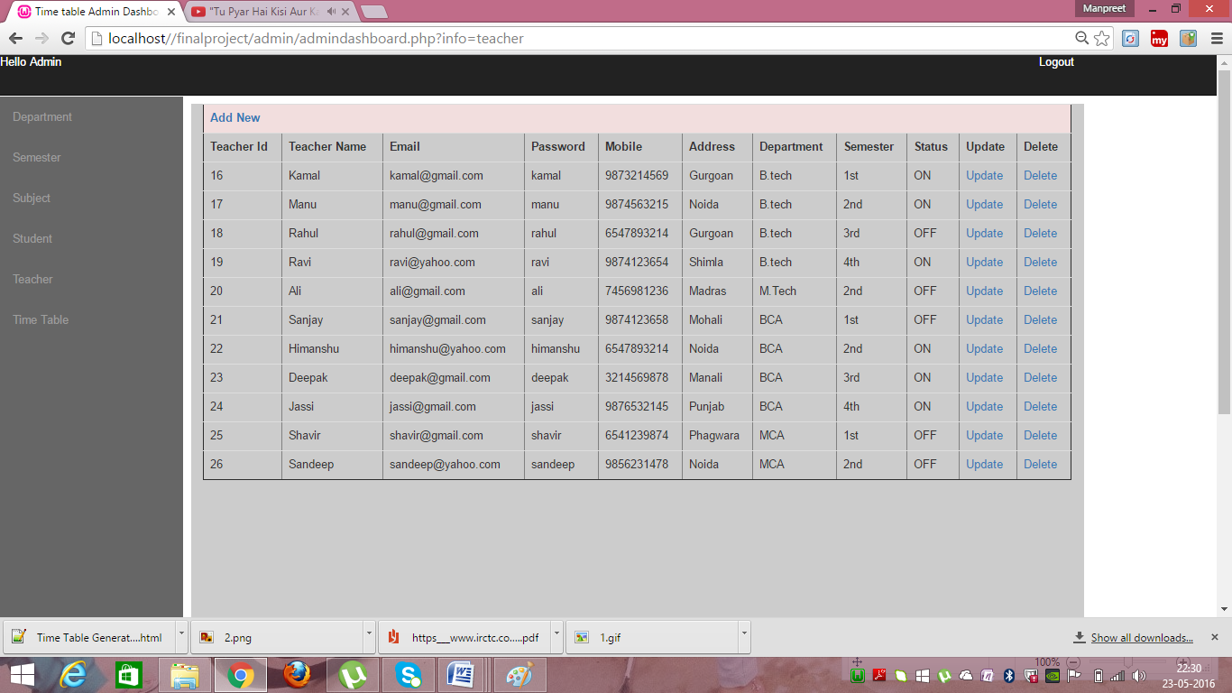

**Time Schedule:**

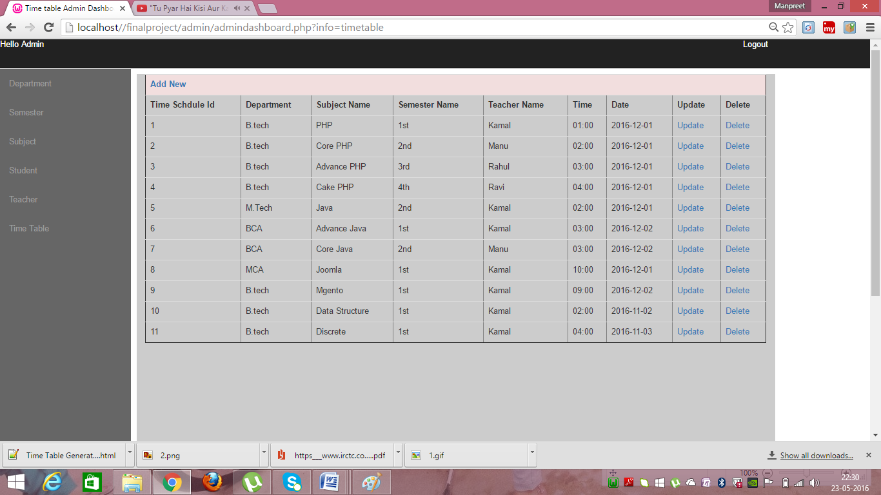

**Add Department:**

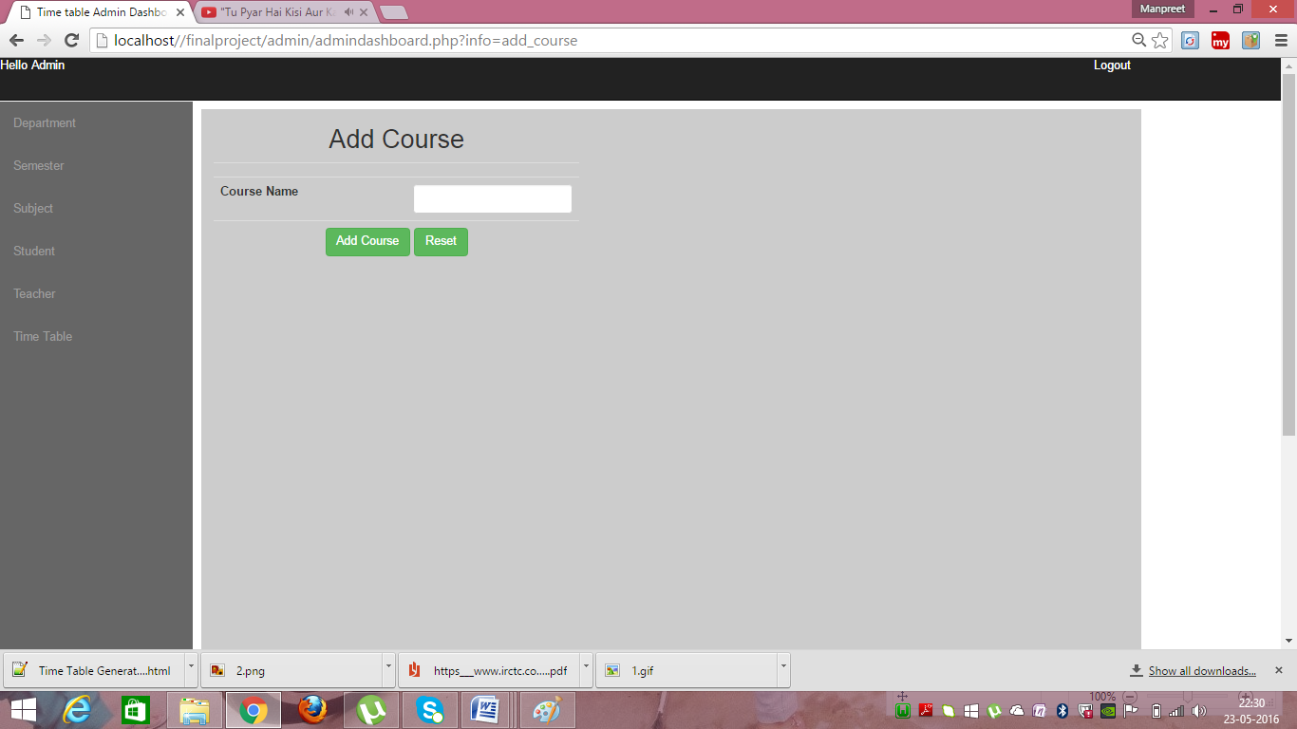

**Add Semester:**

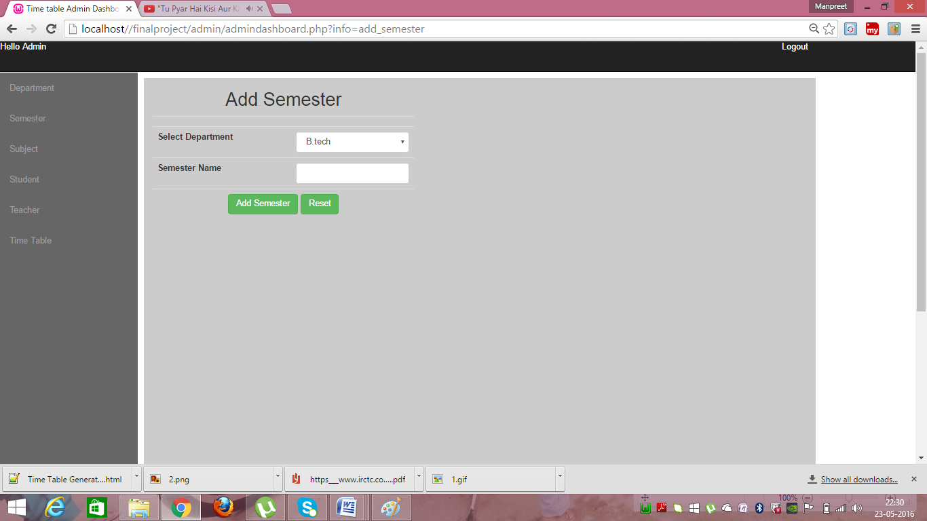

**Add Subject:**

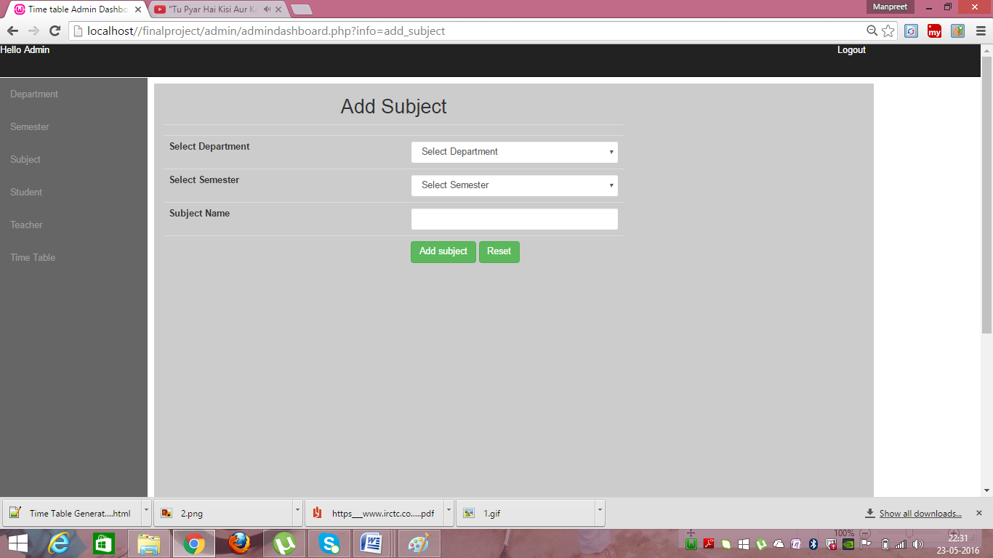

**Add Student:**

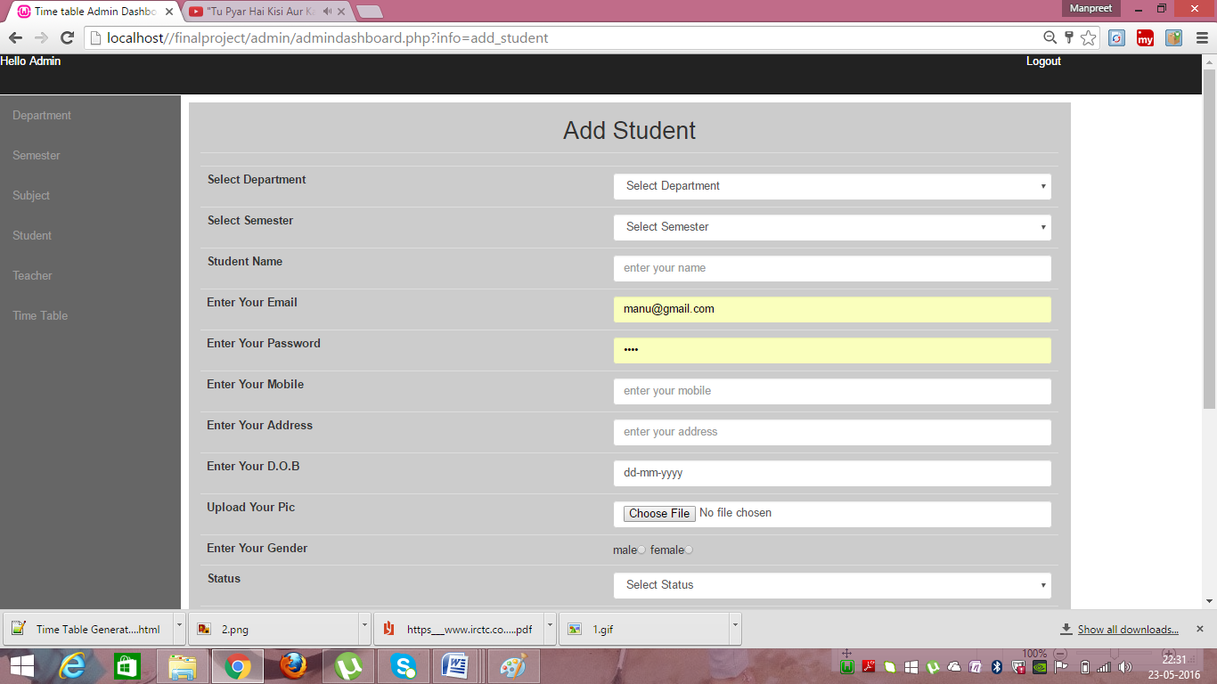

**Add Teacher:**

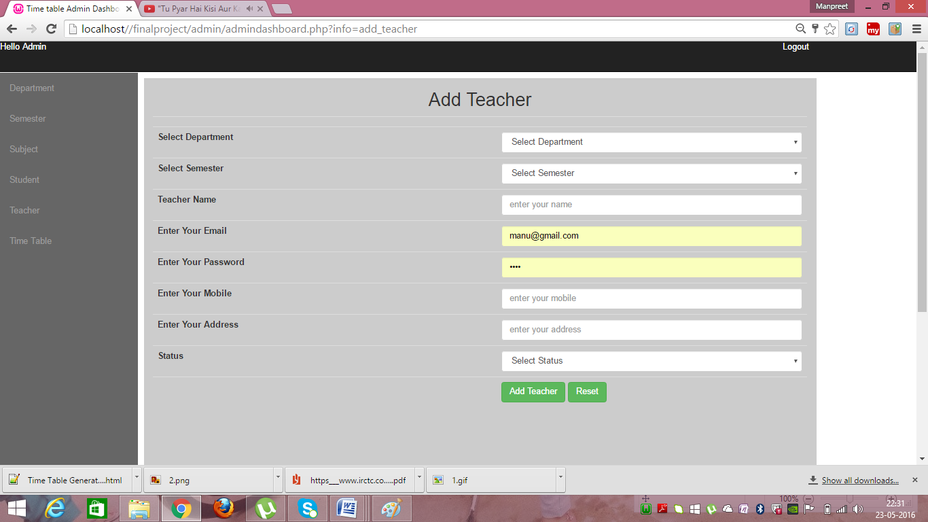

**Add Time Table:**

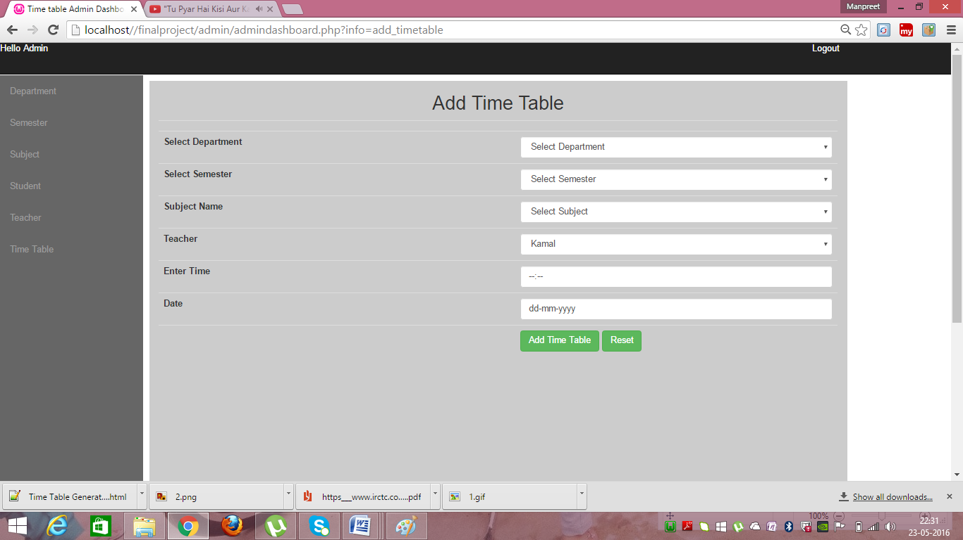

**13. Conclusion**

Time Table Generator is a convenient time table managing website .Time table management may be aided by a range of skills, tools, and techniques used to [manage](https://en.wikipedia.org/wiki/Management) time table when accomplishing specific subjects, semesters, and students. Initially, time table management referred to just work activities, but eventually the term broadened to include personal activities as well. A time table management system is a designed combination of processes, tools, techniques, and methods. Timetable management is usually a necessity in [project development](https://en.wikipedia.org/wiki/Project_development) as it determines the project completion time and scope..  
 

**14. Bibliography**

1. www.phptpoint
2. [www.javascriptkit.com](http://www.javascriptkit.com)
3. [www.tutorialspoint.com/php/](http://www.tutorialspoint.com/php/)
4. W3 school.com

 